UNITED STATES
SECURITIES AND EXCHANGE COMMISSION
Washington, D.C. 20549

SCHEDULE 14A

Proxy Statement Pursuant to Section 14(a) of
the Securities Exchange Act of 1934 (Amendment No. )

Filed by the Registrant ☒

Filed by a Party other than the Registrant ☐

Check the appropriate box:

☐ | Preliminary Proxy Statement

☐ | Confidential, for Use of the Commission Only (as permitted by Rule 14a-6(e)(2))

☐ | Definitive Proxy Statement

☒ | Definitive Additional Materials

☐ | Soliciting Material under §240.14a-12

COHERENT CORP.
(Name of Registrant as Specified In Its Charter)

(Name of Person(s) Filing Proxy Statement, if other than the Registrant)

Payment of Filing Fee (Check the appropriate box):

☒ | No fee required.

☐ | Fee paid previously with preliminary materials.

☐ | Fee computed on table in exhibit required by Item 25(b) per Exchange Act Rules 14a6(i)(1) and 0-11

 | 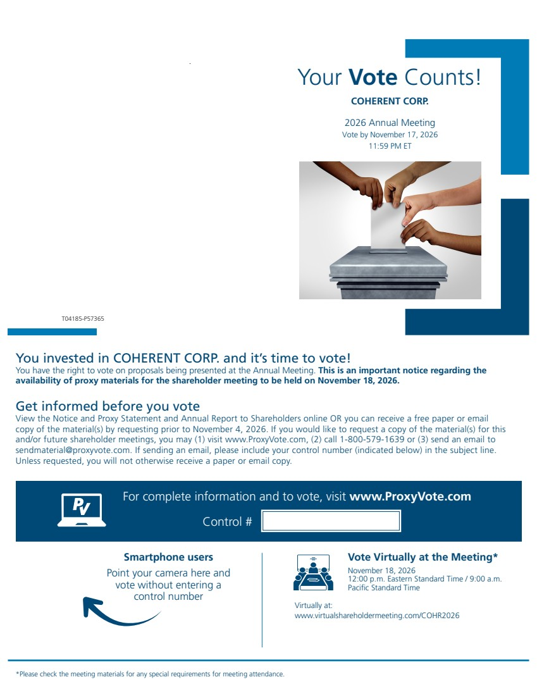 | Smartphone users Point your camera here and vote without entering a control number Your Vote Counts! For complete information and to vote, visit www.ProxyVote.com Control # T04185-P57365 Vote Virtually at the Meeting* November 18, 2026 12:00 p.m. Eastern Standard Time / 9:00 a.m. Pacific Standard Time Virtually at: www.virtualshareholdermeeting.com/COHR2026 *Please check the meeting materials for any special requirements for meeting attendance. COHERENT CORP. 2026 Annual Meeting Vote by November 17, 2026 11:59 PM ET You invested in COHERENT CORP. and it’s time to vote! You have the right to vote on proposals being presented at the Annual Meeting. This is an important notice regarding the availability of proxy materials for the shareholder meeting to be held on November 18, 2026. Get informed before you vote View the Notice and Proxy Statement and Annual Report to Shareholders online OR you can receive a free paper or email copy of the material(s) by requesting prior to November 4, 2026. If you would like to request a copy of the material(s) for this and/or future shareholder meetings, you may (1) visit www.ProxyVote.com, (2) call 1-800-579-1639 or (3) send an email to sendmaterial@proxyvote.com. If sending an email, please include your control number (indicated below) in the subject line. Unless requested, you will not otherwise receive a paper or email copy.
 | 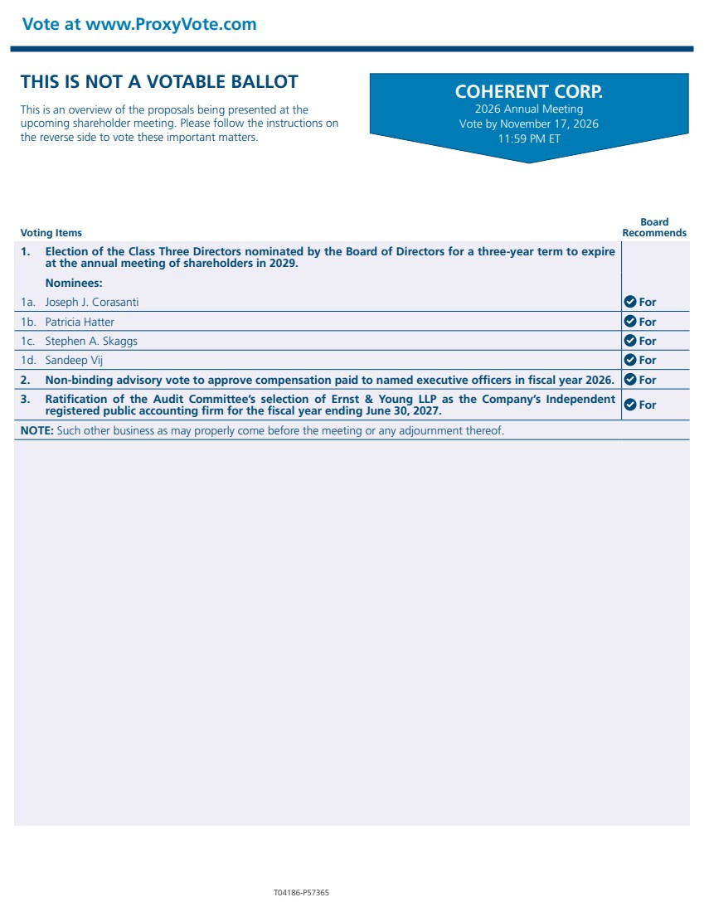 | Vote at www.ProxyVote.com T04186-P57365 Voting Items Board Recommends COHERENT CORP. 2026 Annual Meeting Vote by November 17, 2026 11:59 PM ET THIS IS NOT A VOTABLE BALLOT This is an overview of the proposals being presented at the upcoming shareholder meeting. Please follow the instructions on the reverse side to vote these important matters. 1. Election of the Class Three Directors nominated by the Board of Directors for a three-year term to expire at the annual meeting of shareholders in 2029. Nominees: 1a. Joseph J. Corasanti For 1b. Patricia Hatter For 1c. Stephen A. Skaggs For 1d. Sandeep Vij For 2. Non-binding advisory vote to approve compensation paid to named executive officers in fiscal year 2026. For 3. Ratification of the Audit Committee’s selection of Ernst & Young LLP as the Company’s Independent registered public accounting firm for the fiscal year ending June 30, 2027. For NOTE: Such other business as may properly come before the meeting or any adjournment thereof.

