UNITED STATES
SECURITIES AND EXCHANGE COMMISSION
Washington, D.C. 20549

FORM 8-K

CURRENT REPORT
Pursuant to Section 13 or 15(d)
of the Securities Exchange Act of 1934
Date of Report (Date of earliest event reported): August 12, 2026

Coherent Corp.
(Exact name of registrant as specified in its charter)

Pennsylvania |  | 001-39375 |  | 25-1214948
(State or Other Jurisdiction  of Incorporation) |  | (Commission  File Number) |  | (I.R.S. Employer  Identification No.)
375 Saxonburg Boulevard
Saxonburg, Pennsylvania 16056
(Address of Principal Executive Offices) (Zip Code)
(724) 352-4455
(Registrant’s telephone number, including area code)
Not Applicable
(Former name or former address, if changed since last report)

Check the appropriate box below if the Form 8-K filing is intended to simultaneously satisfy the filing obligation of the registrant under any of the following provisions:

☐ | Written communications pursuant to Rule 425 under the Securities Act (17 CFR 230.425)

☐ | Soliciting material pursuant to Rule 14a-12 under the Exchange Act (17 CFR 240.14a-12)

☐ | Pre-commencement communications pursuant to Rule 14d-2(b) under the Exchange Act (17 CFR 240.14d-2(b))

☐ | Pre-commencement communications pursuant to Rule 13e-4(c) under the Exchange Act (17 CFR 240.13e-4(c))
Securities registered pursuant to Section 12(b) of the Act:

Title of each class |  | Trading  Symbol(s) |  | Name of each exchange  on which registered
Common Stock, no par value |  | COHR |  | New York Stock Exchange
Indicate by check mark whether the registrant is an emerging growth company as defined in Rule 405 of the Securities Act of 1933 (§230.405 of this chapter) or Rule 12b-2 of the Securities Exchange Act of 1934 (§240.12b-2 of this chapter).
Emerging growth company ☐
If an emerging growth company, indicate by check mark if the registrant has elected not to use the extended transition period for complying with any new or revised financial accounting standards provided pursuant to Section 13(a) of the Exchange Act. ☐

Item 2.02. | Results of Operations and Financial Condition.
On August 12, 2026, Coherent Corp. (the “Company”) issued a press release reporting its financial results for the fourth quarter of fiscal year 2026 ended June 30, 2026, a copy of which is attached hereto as Exhibit 99.1 and is incorporated herein by reference.
The information in Item 2.02 of this Current Report on Form 8-K, including Exhibit 99.1 furnished pursuant to Item 9.01, shall not be deemed “filed” for the purposes of Section 18 of the Securities Exchange Act of 1934 or otherwise subject to the liabilities under that Section. Furthermore, the information in this Item 2.02 of this Current Report on Form 8-K, including Exhibit 99.1 furnished pursuant to Item 9.01, shall not be deemed to be incorporated by reference into the filings of the Company under the Securities Act of 1933.

Item 7.01. | Regulation FD Disclosure.
A slide presentation to be used by senior management of the Company in connection with its discussions with investors and others regarding the financial results is furnished as Exhibit 99.2.
The information in this Item 7.01 of this Current Report on Form 8-K, including Exhibit 99.2 furnished pursuant to Item 9.01, shall not be deemed “filed” for the purposes of Section 18 of the Securities Exchange Act of 1934 or otherwise subject to the liabilities under that Section. Furthermore, the information in this Item 7.01 of this Current Report on Form 8-K, including Exhibit 99.2 furnished pursuant to Item 9.01, shall not be deemed to be incorporated by reference into the filings of the Company under the Securities Act of 1933.

Item 9.01. | Financial Statements and Exhibits.
(d) Exhibits

Exhibit  No. |  | Description
99.1 |  | Press Release dated August 12, 2026
99.2 |  | Investor Presentation
104.0 |  | Cover Page Interactive Data File (embedded within the inline XBRL document)

SIGNATURE
Pursuant to the requirements of the Securities Exchange Act of 1934, the registrant has duly caused this report to be signed on its behalf by the undersigned hereunto duly authorized.

 |  |  |  | Coherent Corp.
Date: August 12, 2026 |  |  |  | By: |  | /s/ Sherri Luther
 |  |  |  |  |  | Sherri Luther
 |  |  |  |  |  | Chief Financial Officer and Treasurer
Exhibit 99.1

 |  |  |  |  |  | Coherent Corp.  375 Saxonburg Blvd.  Saxonburg, PA 16056-9499
PRESS RELEASE
COHERENT CORP. REPORTS FOURTH QUARTER AND FULL YEAR FISCAL 2026 RESULTS

 |  |  | Q4 REVENUE OF $2.05B, INCREASED 34% Y/Y AND 42% Y/Y ON A PRO FORMA BASIS

 |  |  | Q4 GAAP GROSS MARGIN OF 38.5%, INCREASED 277 bps Y/Y; Q4 NON-GAAP GROSS MARGIN OF 40.2%, INCREASED 215 bps Y/Y

 |  |  | Q4 GAAP EPS OF $1.19, INCREASED $2.02 Y/Y; Q4 NON-GAAP EPS OF $1.74, INCREASED $0.74 Y/Y
SAXONBURG, Pa., August 12, 2026 – Coherent Corp. (NYSE: COHR) (“Coherent,” “We,” or the “Company”), a global leader in photonics, announced financial results today for its fiscal fourth quarter and full year fiscal 2026 ended June 30, 2026.
Revenue for the fourth quarter of fiscal 2026 was $2.05 billion, with GAAP gross margin of 38.5% and GAAP net income of $1.19 per diluted share. On a non-GAAP basis, gross margin was 40.2% with net income per diluted share of $1.74.
“Fiscal 2026 was an outstanding year for Coherent, with record revenue, significant margin expansion, and non-GAAP EPS growth that was more than twice the rate of revenue growth,” said Jim Anderson, CEO. “We enter fiscal 2027 with exceptional customer demand, expanding production capacity, and multiple new growth platforms beginning to ramp. As AI datacenter architectures increasingly transition from copper to optical connectivity, we believe Coherent’s broad photonic technology portfolio and manufacturing scale uniquely position us to deliver accelerating growth and capitalize on this multi-year opportunity.”
Sherri Luther, CFO, said, “Strong operational execution across our business drove meaningful gross margin expansion and converted our top-line revenue growth into robust GAAP and non-GAAP EPS growth. As we enter fiscal 2027, we remain disciplined in our capital allocation, prioritizing investments to expand manufacturing capacity so we can efficiently fulfill the ongoing acceleration in customer demand.”

1

Selected Fourth Quarter and Full Year 2026 Financial Results and Comparisons (in millions, except percentages and per share data)
Table 1

 |  | GAAP Financial Results (unaudited)
 |  | Q4 FY26 |  |  |  | Q3 FY26 |  |  |  | Q4 FY25 |  |  |  | Q/Q |  |  |  | Y/Y |  |  |  | FY 2026 |  |  |  | FY 2025 |  |  |  | FY/FY
Revenues |  | $ | 2,046 |  |  | $ | 1,806 |  |  | $ | 1,529 |  |  |  | 13.3 | % |  |  | 33.8 | % |  | $ | 7,118 |  |  | $ | 5,810 |  |  |  | 22.5 | %
Gross Margin % |  |  | 38.5 | % |  |  | 37.7 | % |  |  | 35.7 | % |  |  | 82 | bps |  |  | 277 | bps |  |  | 37.5 | % |  |  | 35.2 | % |  |  | 233 | bps
R&D Expense % |  |  | 10.6 | % |  |  | 10.3 | % |  |  | 10.2 | % |  |  | 28 | bps |  |  | 40 | bps |  |  | 10.2 | % |  |  | 10.0 | % |  |  | 14 | bps
SG&A Expense % |  |  | 13.0 | % |  |  | 14.8 | % |  |  | 16.0 | % |  |  | (180 | ) bps |  |  | (302 | ) bps |  |  | 14.7 | % |  |  | 15.9 | % |  |  | (127 | ) bps
Operating Expenses |  | $ | 533 |  |  | $ | 479 |  |  | $ | 540 |  |  |  | 11.2 | % |  |  | (1.3 | )% |  | $ | 1,771 |  |  | $ | 1,753 |  |  |  | 1.0 | %
Operating Income(1) |  | $ | 254 |  |  | $ | 201 |  |  | $ | 6 |  |  |  | 26.5 | % |  |  | 4063.9 | % |  | $ | 898 |  |  | $ | 290 |  |  |  | 209.7 | %
Operating Margin |  |  | 12.4 | % |  |  | 11.1 | % |  |  | 0.4 | % |  |  | 130 | bps |  |  | 1,202 | bps |  |  | 12.6 | % |  |  | 5.0 | % |  |  | 762 | bps
Net Earnings Attributable to Coherent Corp. |  | $ | 241 |  |  | $ | 191 |  |  | $ | (96 | ) |  |  | 25.8 | % |  |  | (351.6 | )% |  | $ | 805 |  |  | $ | 49 |  |  |  | 1530.8 | %
Diluted Earnings (Loss) Per Share |  | $ | 1.19 |  |  | $ | 0.97 |  |  | $ | (0.83 | ) |  | $ | 0.22 |  |  | $ | 2.02 |  |  | $ | 4.12 |  |  | $ | (0.52 | ) |  | $ | 4.64

(1) | Operating Income is defined as earnings (loss) before income taxes, interest expense, and other expense or income, net.

Selected Fourth Quarter and Full Year 2026 Financial Results and Comparisons (in millions, except percentages and per share data)
Table 1, continued

 |  | Non-GAAP Financial Results (unaudited)(1)(2)
 |  | Q4 FY26 |  |  |  | Q3 FY26 |  |  |  | Q4 FY25 |  |  |  | Q/Q |  |  |  | Y/Y |  |  |  | FY 2026 |  |  |  | FY 2025 |  |  |  | FY/FY
Revenues |  | $ | 2,046 |  |  | $ | 1,806 |  |  | $ | 1,529 |  |  |  | 13.3 | % |  |  | 33.8 | % |  | $ | 7,118 |  |  | $ | 5,810 |  |  |  | 22.5 | %
Gross Margin % |  |  | 40.2 | % |  |  | 39.6 | % |  |  | 38.1 | % |  |  | 66 | bps |  |  | 215 | bps |  |  | 39.4 | % |  |  | 37.9 | % |  |  | 152 | bps
R&D Expense % |  |  | 10.2 | % |  |  | 9.9 | % |  |  | 9.8 | % |  |  | 30 | bps |  |  | 39 | bps |  |  | 9.7 | % |  |  | 9.5 | % |  |  | 20 | bps
SG&A Expense % |  |  | 8.2 | % |  |  | 9.4 | % |  |  | 10.3 | % |  |  | (116 | ) bps |  |  | (205 | ) bps |  |  | 9.2 | % |  |  | 10.5 | % |  |  | (130 | ) bps
Operating Expenses |  | $ | 377 |  |  | $ | 348 |  |  | $ | 307 |  |  |  | 8.2 | % |  |  | 22.7 | % |  | $ | 1,350 |  |  | $ | 1,165 |  |  |  | 15.8 | %
Operating Income |  | $ | 446 |  |  | $ | 366 |  |  | $ | 275 |  |  |  | 21.8 | % |  |  | 62.1 | % |  | $ | 1,457 |  |  | $ | 1,037 |  |  |  | 40.5 | %
Operating Margin |  |  | 21.8 | % |  |  | 20.3 | % |  |  | 18.0 | % |  |  | 152 | bps |  |  | 381 | bps |  |  | 20.5 | % |  |  | 17.8 | % |  |  | 262 | bps
Net Earnings Attributable to Coherent Corp. |  | $ | 351 |  |  | $ | 276 |  |  | $ | 192 |  |  |  | 27.2 | % |  |  | 82.7 | % |  | $ | 1,097 |  |  | $ | 693 |  |  |  | 58.3 | %
Diluted Earnings Per Share |  | $ | 1.74 |  |  | $ | 1.41 |  |  | $ | 1.00 |  |  | $ | 0.33 |  |  | $ | 0.74 |  |  | $ | 5.61 |  |  | $ | 3.53 |  |  | $ | 2.08

(1) | During the second fiscal quarter of 2025, the Company refined its methodology to report non-GAAP measures. The change does not impact the Company’s financial position, cash flows, or GAAP consolidated results of operations. Prior period non-GAAP financial measures presented in this press release have been recast to conform to the current presentation.
(2) | The Company has disclosed financial measurements in this earnings release that present financial information that are considered to be non-GAAP financial measures. These measurements are not a substitute for GAAP measurements, although the Company’s management uses these measurements as an aid in monitoring the Company’s on-going financial performance. The non-GAAP net earnings attributable to Coherent Corp., the non-GAAP diluted earnings per share, the non-GAAP operating income, the non-GAAP gross margin, the non-GAAP research and development, the non-GAAP selling, general and administrative expenses, the non-GAAP operating expenses, the non-GAAP interest and other (income) expense, and the non-GAAP income taxes, measure earnings and operating income (loss), respectively, excluding non-recurring or unusual items that are considered by management to be outside the Company’s standard operation and excluding certain non-cash items. There are limitations associated with the use of non-GAAP financial measures, including that such measures may not be entirely

2

comparable to similarly titled measures used by other companies, due to potential differences among calculation methodologies. Thus, there can be no assurance whether (i) items excluded from the non-GAAP financial measures will occur in the future or (ii) there will be cash costs associated with items excluded from the non-GAAP financial measures. The Company compensates for these limitations by using these non-GAAP financial measures as supplements to GAAP financial measures and by providing the reconciliations of the non-GAAP financial measures to their most comparable GAAP financial measures. Investors should consider adjusted measures in addition to, and not as a substitute for, or superior to, financial performance measures prepared in accordance with GAAP. All non-GAAP amounts exclude certain adjustments for share-based compensation, acquired intangible amortization expense, restructuring charges (recoveries), impairments of assets held-for-sale, gains on sale of business, integration and site consolidation expenses, integration transaction expenses, and various one-time adjustments. See Table 6 for the Reconciliation of GAAP Measures to Non-GAAP Measures.
Business Outlook – First Quarter Fiscal 2027(1)

 |  |  | Revenue for the first quarter of fiscal 2027 is expected to be between $2.2 billion and $2.4 billion.

 |  |  | Gross margin percentage for the first quarter of fiscal 2027 is expected to be between 39.5% and 41.5% on a non-GAAP basis.

 |  |  | Total operating expenses for the first quarter of fiscal 2027 are expected to be between $400 million and $420 million on a non-GAAP basis.

 |  |  | Tax rate for the first quarter of fiscal 2027 is expected to be between 18% and 20% on a non-GAAP basis.

 |  |  | EPS for the first quarter of fiscal 2027 is expected to be between $1.85 and $2.05 on a non-GAAP basis.

(1) | The Company has not provided a quantitative reconciliation of forward-looking non-GAAP gross margin percentage, non-GAAP operating expenses, non-GAAP tax rate and non-GAAP earnings per share, because we cannot, without unreasonable efforts, forecast certain items required to develop comparable GAAP measures. These items include, without limitation, restructuring charges, integration, site consolidation and other expenses, foreign exchange gains (losses), and share based compensation expense. The variability of these items could significantly impact our future GAAP financial results and we believe that the inclusion of any such reconciliations would imply a degree or precision that could be confusing or misleading to investors.
Investor Conference Call / Webcast Details
Coherent will review the Company’s financial results for its fourth quarter and full year fiscal 2026 and business outlook on Wednesday, August 12, at 4:30 p.m. ET. A live webcast and replay of the conference call will be available on the Investor Relations section of the Company’s website at coherent.com/company/investor-relations. The Company’s financial guidance will be limited to the comments on its public quarterly earnings call and the public business outlook statements contained in this press release.
Additional Information and Where to Find It
In connection with the conference call described above, the Company intends to file an investor presentation as an exhibit to a Current Report on Form 8-K filed with the Securities and Exchange Commission (“SEC”) and to post the investor presentation on the Company’s website at coherent.com/company/investor-relations/investor-presentations after market close on August 12, 2026. We also may, from time to time, post other important information for investors on our website at coherent.com/company/investor-relations. We intend to use our website as a means of disclosing material, non-public information and for complying with our disclosure obligations under Regulation FD. Accordingly, investors should review the Investor Relations page of our website referenced above, in addition to following the Company’s press releases, SEC filings, and public conference calls, presentations, and webcasts. Investors and security holders are

3

able to obtain free copies of these documents through the Company’s website referenced above. Copies of the documents filed by the Company with the SEC may be obtained free of charge on the Company’s website at coherent.com/company/investor-relations/sec-filings. The information contained on, or that may be accessed through, the Company’s website is not incorporated by reference into, and is not part of, this release.
Forward-Looking Statements
This press release contains statements, estimates, and projections that constitute “forward-looking statements” as defined under U.S. federal securities laws – including our estimates and projections for our business outlook for the first quarter of fiscal 2027, each of which is made pursuant to the safe harbor provisions of the U.S. Private Securities Litigation Reform Act of 1995 and relate to the Company’s performance on a going-forward basis. The forward-looking statements are subject to certain risks and uncertainties that could cause the Company’s actual results to differ materially from its historical experience and our present expectations or projections.
The Company believes that all forward-looking statements made by it herein have a reasonable basis, but there can be no assurance that management’s expectations, beliefs, or projections as expressed in the forward-looking statements will actually occur or prove to be correct. In addition to general industry and global economic conditions, factors that could cause actual results to differ materially from those discussed in the forward-looking statements herein include but are not limited to: (i) the failure of any one or more of the assumptions stated herein to prove to be correct; (ii) changes in demand in the Company’s end markets along with the Company’s ability to respond to such market changes; (iii) our failure to accurately estimate customer demand and future sales and/or fluctuations in purchasing patterns of customers and end users; (iv) the ability of the Company to retain and hire key employees; (v) the terms of the Company’s indebtedness and ability to service such debt; (vi) the timely release of new products and acceptance of such new products by the market; (vii) the introduction of new products by competitors and other competitive responses; (viii) the risks to realizing the benefits of investments in R&D and commercialization of innovations; (ix) the risks that the Company’s stock price will not trade in line with industrial technology leaders; (x) the impact of international conflict and economic volatility in either domestic or foreign markets, including risks related to the impact of trade protection measures, such as import tariffs by the United States or retaliatory actions taken by other countries; and/or (xi) the risks relating to forward-looking statements and other “Risk Factors” identified from time to time in our filings with the SEC, including our Annual Report on Form 10-K for the fiscal year ended June 30, 2025, and our subsequently filed Quarterly Reports on Form 10-Q and Annual Report on Form 10-K for the fiscal year ended June 30, 2026, which filings are available from the SEC. You should not place undue reliance on forward-looking statements, which speak only as of the date they are made. The Company disclaims any obligation to update information contained in these forward-looking statements, whether as a result of new information, future events or developments, or otherwise.

4

About Coherent
Coherent is the global photonics leader. We harness photons to drive innovation. Industry leaders in the datacenter, communications, and industrial markets rely on Coherent’s world-leading technology to fuel their own innovation and growth.
Founded in 1971 and operating in more than 20 countries, Coherent brings the industry’s broadest, deepest technology stack; unmatched supply chain resilience; and global scale to help its customers solve their toughest technology challenges. For more information, please visit us at coherent.com.
Contact:
Paul Silverstein
Senior VP, Investor Relations
investor.relations@coherent.com
# # #

5

Table 2
Coherent Corp. and Subsidiaries
Condensed Consolidated Statements of Earnings (Loss)*

 |  | THREE MONTHS ENDED
$ Millions, except per share amounts (unaudited) |  | Jun 30, 2026 |  |  |  | Mar 31, 2026 |  |  |  | Jun 30, 2025
Revenues |  | $ | 2,045.5 |  |  | $ | 1,805.6 |  |  | $ | 1,529.4
Costs, Expenses & Other Expense (Income)
Cost of goods sold |  |  | 1,258.5 |  |  |  | 1,125.7 |  |  |  | 983.3
Research and development |  |  | 216.4 |  |  |  | 186.0 |  |  |  | 155.7
Selling, general and administrative |  |  | 266.4 |  |  |  | 267.6 |  |  |  | 245.4
Restructuring charges |  |  | 6.1 |  |  |  | 34.4 |  |  |  | 53.9
Impairment of assets held-for-sale |  |  | 44.3 |  |  |  | — |  |  |  | 85.0
Gain on sale of business |  |  | — |  |  |  | (8.9 | ) |  |  | —
Interest expense |  |  | 41.1 |  |  |  | 44.6 |  |  |  | 55.0
Other expense (income), net |  |  | (65.6 | ) |  |  | (28.1 | ) |  |  | 14.4
Total Costs, Expenses, & Other Expense |  |  | 1,767.0 |  |  |  | 1,621.3 |  |  |  | 1,592.9
Earnings (Loss) Before Income Taxes |  |  | 278.5 |  |  |  | 184.3 |  |  |  | (63.4 | )
Income Taxes |  |  | 42.3 |  |  |  | 2.7 |  |  |  | 34.7
Net Earnings (Loss) |  |  | 236.2 |  |  |  | 181.7 |  |  |  | (98.1 | )
Net Loss Attributable to Noncontrolling Interests |  |  | (4.3 | ) |  |  | (9.7 | ) |  |  | (2.5 | )
Net Earnings (Loss) Attributable to Coherent Corp. |  |  | 240.5 |  |  |  | 191.4 |  |  |  | (95.6 | )
Less: Dividends on Preferred Stock |  |  | — |  |  |  | — |  |  |  | 33.1
Net Earnings (Loss) Available to the Common Shareholders |  | $ | 240.5 |  |  | $ | 191.4 |  |  | $ | (128.8 | )
Basic Earnings (Loss) Per Share |  | $ | 1.23 |  |  | $ | 1.01 |  |  | $ | (0.83 | )
Diluted Earnings (Loss) Per Share |  | $ | 1.19 |  |  | $ | 0.97 |  |  | $ | (0.83 | )
Average Shares Outstanding - Basic |  |  | 195.7 |  |  |  | 190.2 |  |  |  | 155.5
Average Shares Outstanding - Diluted |  |  | 202.2 |  |  |  | 196.4 |  |  |  | 155.5

* | Amounts may not recalculate due to rounding.

6

Table 2
Coherent Corp. and Subsidiaries
Condensed Consolidated Statements of Earnings*
(Continued)

 |  | YEAR ENDED
$ Millions, except per share amounts (unaudited) |  | Jun 30, 2026 |  |  |  | Jun 30, 2025
Revenues |  | $ | 7,118.2 |  |  | $ | 5,810.1
Costs, Expenses & Other Expense (Income)
Cost of goods sold |  |  | 4,449.1 |  |  |  | 3,766.8
Research and development |  |  | 723.0 |  |  |  | 581.9
Selling, general and administrative |  |  | 1,044.6 |  |  |  | 926.5
Restructuring charges |  |  | 63.4 |  |  |  | 160.1
Impairment of assets held-for-sale |  |  | 64.4 |  |  |  | 85.0
Gain on sale of business |  |  | (124.1 | ) |  |  | —
Interest expense |  |  | 190.3 |  |  |  | 243.3
Other expense (income), net |  |  | (140.1 | ) |  |  | (47.6 | )
Total Costs, Expenses, & Other Expense |  |  | 6,270.4 |  |  |  | 5,715.9
Earnings Before Income Taxes |  |  | 847.7 |  |  |  | 94.2
Income Taxes |  |  | 60.8 |  |  |  | 64.1
Net Earnings |  |  | 786.9 |  |  |  | 30.1
Net Loss Attributable to Noncontrolling Interests |  |  | (18.1 | ) |  |  | (19.3 | )
Net Earnings Attributable to Coherent Corp. |  |  | 805.0 |  |  |  | 49.4
Less: Dividends on Preferred Stock |  |  | 35.1 |  |  |  | 129.9
Net Earnings (Loss) Available to the Common Shareholders |  | $ | 769.9 |  |  | $ | (80.6 | )
Basic Earnings (Loss) Per Share |  | $ | 4.34 |  |  | $ | (0.52 | )
Diluted Earnings (Loss) Per Share |  | $ | 4.12 |  |  | $ | (0.52 | )
Average Shares Outstanding - Basic |  |  | 177.3 |  |  |  | 154.8
Average Shares Outstanding - Diluted |  |  | 195.4 |  |  |  | 154.8

* | Amounts may not recalculate due to rounding.

7

Table 3
Coherent Corp. and Subsidiaries
Condensed Consolidated Balance Sheets*

$ Millions (unaudited) |  | Jun 30, 2026 |  |  |  | Jun 30, 2025
Assets
Current Assets
Cash and cash equivalents |  | $ | 1,162.0 |  |  | $ | 909.2
Restricted cash, current |  |  | 35.2 |  |  |  | 8.9
Short-term investments |  |  | 825.0 |  |  |  | —
Accounts receivable |  |  | 1,343.3 |  |  |  | 964.1
Inventories |  |  | 2,581.0 |  |  |  | 1,437.6
Prepaid and refundable income taxes |  |  | 78.9 |  |  |  | 55.8
Prepaid and other current assets |  |  | 900.1 |  |  |  | 551.6
Total Current Assets |  |  | 6,925.5 |  |  |  | 3,927.2
Property, plant & equipment, net |  |  | 2,999.3 |  |  |  | 1,877.5
Goodwill |  |  | 4,375.6 |  |  |  | 4,471.1
Other intangible assets, net |  |  | 2,884.5 |  |  |  | 3,204.7
Deferred income taxes |  |  | 69.4 |  |  |  | 53.4
Restricted cash, non-current |  |  | 571.2 |  |  |  | 714.8
Other assets |  |  | 474.3 |  |  |  | 662.2
Total Assets |  | $ | 18,299.9 |  |  | $ | 14,910.9
Liabilities, Mezzanine Equity and Equity
Current Liabilities
Current portion of long-term debt |  | $ | 7.9 |  |  | $ | 188.3
Accounts payable |  |  | 1,905.4 |  |  |  | 847.0
Operating lease current liabilities |  |  | 61.4 |  |  |  | 41.6
Accruals and other current liabilities |  |  | 879.3 |  |  |  | 718.0
Total Current Liabilities |  |  | 2,853.9 |  |  |  | 1,794.8
Long-term debt |  |  | 3,214.3 |  |  |  | 3,498.6
Deferred income taxes |  |  | 540.6 |  |  |  | 711.7
Operating lease liabilities |  |  | 254.8 |  |  |  | 165.2
Other liabilities |  |  | 198.0 |  |  |  | 259.3
Total Liabilities |  |  | 7,061.7 |  |  |  | 6,429.7
Total Mezzanine Equity |  |  | — |  |  |  | 2,483.3
Total Coherent Corp. Shareholders’ Equity |  |  | 10,903.5 |  |  |  | 5,644.5
Noncontrolling interests |  |  | 334.7 |  |  |  | 353.5
Total Equity |  |  | 11,238.2 |  |  |  | 5,998.0
Total Liabilities, Mezzanine Equity and Equity |  | $ | 18,299.9 |  |  | $ | 14,910.9

* | Amounts may not recalculate due to rounding.

8

Table 4
Coherent Corp. and Subsidiaries
Condensed Consolidated Statements of Cash Flows*

 |  | YEAR ENDED
$ Millions (unaudited) |  | Jun 30, 2026 |  |  |  | Jun 30, 2025
Cash Flows from Operating Activities
Net cash provided by operating activities |  | $ | 79.5 |  |  | $ | 633.6
Cash Flows from Investing Activities
Additions to property, plant & equipment |  |  | (1,102.9 | ) |  |  | (440.8 | )
Purchases of intangible assets |  |  | (7.2 | ) |  |  | —
Proceeds from the sale of business |  |  | 437.0 |  |  |  | 27.0
Proceeds from sale of equity investment |  |  | 89.4 |  |  |  | —
Purchases of short-term investments |  |  | (1,025.0 | ) |  |  | —
Proceeds from sales/maturities of short-term investments |  |  | 200.0 |  |  |  | —
Other investing activities |  |  | (5.0 | ) |  |  | (0.4 | )
Net cash used in investing activities |  |  | (1,413.7 | ) |  |  | (414.2 | )
Cash Flows from Financing Activities
Proceeds from borrowings of Term A Facility |  |  | 1,250.0 |  |  |  | —
Proceeds from borrowings of Term B Facility |  |  | 3.3 |  |  |  | —
Proceeds from borrowings of revolving credit facilities |  |  | 640.1 |  |  |  | 53.7
Proceeds from borrowings of other credit facilities |  |  | 28.0 |  |  |  | —
Proceeds from issuance of common shares |  |  | 1,998.6 |  |  |  | —
Payments on existing debt |  |  | (1,723.4 | ) |  |  | (437.0 | )
Payments on borrowings under revolving credit facilities |  |  | (676.2 | ) |  |  | (51.7 | )
Debt issuance costs |  |  | (9.1 | ) |  |  | —
Proceeds from exercises of stock options and purchases under employee stock purchase plan |  |  | 53.8 |  |  |  | 49.6
Payments in satisfaction of employees’ minimum tax obligations |  |  | (77.4 | ) |  |  | (54.0 | )
Payment of dividends |  |  | (11.4 | ) |  |  | (11.4 | )
Other financing activities |  |  | 1.0 |  |  |  | (0.9 | )
Net cash provided by (used in) financing activities |  |  | 1,477.1 |  |  |  | (451.7 | )
Effect of exchange rate changes on cash and cash equivalents |  |  | (7.4 | ) |  |  | 75.6
Net increase (decrease) in cash and cash equivalents |  |  | 135.5 |  |  |  | (156.8 | )
Cash, Cash Equivalents, and Restricted Cash at Beginning of Period |  |  | 1,632.9 |  |  |  | 1,789.7
Cash, Cash Equivalents, and Restricted Cash at End of Period |  | $ | 1,768.4 |  |  | $ | 1,632.9

* | Amounts may not recalculate due to rounding.

9

Table 5
Segment Revenues*

 |  | THREE MONTHS ENDED |  |  |  |  |  |  |  |  |  |  |  | YEAR ENDED
$ Millions (unaudited) |  | Jun 30,  2026 |  |  |  | Mar 31,  2026 |  |  |  | Jun 30,  2025 |  |  |  | Jun 30,  2026 |  |  |  | Jun 30,  2025
Revenues:
Datacenter & Communications |  | $ | 1,615.0 |  |  | $ | 1,361.6 |  |  | $ | 1,018.3 |  |  | $ | 5,274.6 |  |  | $ | 3,755.2
Industrial |  |  | 430.5 |  |  |  | 444.0 |  |  |  | 511.1 |  |  |  | 1,843.6 |  |  |  | 2,054.9
Consolidated |  | $ | 2,045.5 |  |  | $ | 1,805.6 |  |  | $ | 1,529.4 |  |  | $ | 7,118.2 |  |  | $ | 5,810.1

* | Amounts may not recalculate due to rounding.

10

Table 6
Reconciliation of GAAP Measures to Non-GAAP Measures*

 |  | THREE MONTHS ENDED |  |  |  |  |  |  |  |  |  |  |  | YEAR ENDED
$ Millions, except per share amounts (unaudited) |  | Jun 30,  2026 |  |  |  | Mar 31,  2026 |  |  |  | Jun 30,  2025 |  |  |  | Jun 30,  2026 |  |  |  | Jun 30,  2025 (1)
Gross margin on GAAP basis |  | $ | 787.1 |  |  | $ | 679.9 |  |  | $ | 546.1 |  |  | $ | 2,669.0 |  |  | $ | 2,043.3
Share-based compensation |  |  | 7.4 |  |  |  | 6.4 |  |  |  | 5.8 |  |  |  | 26.0 |  |  |  | 22.5
Amortization of acquired intangibles |  |  | 27.8 |  |  |  | 27.9 |  |  |  | 30.6 |  |  |  | 111.2 |  |  |  | 135.1
Integration, site consolidation and other(2) |  |  | 0.3 |  |  |  | — |  |  |  | (0.4 | ) |  |  | 0.3 |  |  |  | 1.3
Gross margin on non-GAAP basis |  | $ | 822.6 |  |  | $ | 714.2 |  |  | $ | 582.2 |  |  | $ | 2,806.5 |  |  | $ | 2,202.3
Research & development on GAAP basis |  | $ | 216.4 |  |  | $ | 186.0 |  |  | $ | 155.7 |  |  | $ | 723.0 |  |  | $ | 581.9
Share-based compensation |  |  | (8.0 | ) |  |  | (7.4 | ) |  |  | (5.9 | ) |  |  | (28.9 | ) |  |  | (22.2 | )
Amortization of acquired intangibles |  |  | (0.2 | ) |  |  | (0.2 | ) |  |  | (0.2 | ) |  |  | (0.8 | ) |  |  | (5.3 | )
Integration, site consolidation and other(2) |  |  | — |  |  |  | — |  |  |  | 0.1 |  |  |  | — |  |  |  | (0.2 | )
Research & development on non-GAAP basis |  | $ | 208.3 |  |  | $ | 178.4 |  |  | $ | 149.7 |  |  | $ | 693.3 |  |  | $ | 554.3
Selling, general and administrative on GAAP basis |  | $ | 266.4 |  |  | $ | 267.6 |  |  | $ | 245.4 |  |  | $ | 1,044.6 |  |  | $ | 926.5
Share-based compensation |  |  | (38.5 | ) |  |  | (36.8 | ) |  |  | (32.6 | ) |  |  | (138.9 | ) |  |  | (116.3 | )
Amortization of acquired intangibles |  |  | (41.8 | ) |  |  | (42.4 | ) |  |  | (41.2 | ) |  |  | (168.3 | ) |  |  | (162.4 | )
Financing fees(3) |  |  | — |  |  |  | — |  |  |  | — |  |  |  | (1.1 | ) |  |  | —
Integration, site consolidation and other(2) |  |  | (17.4 | ) |  |  | (18.9 | ) |  |  | (14.4 | ) |  |  | (79.9 | ) |  |  | (36.7 | )
Selling, general and administrative on non-GAAP basis |  | $ | 168.5 |  |  | $ | 169.7 |  |  | $ | 157.3 |  |  | $ | 656.3 |  |  | $ | 611.0
Restructuring charges on GAAP basis |  | $ | 6.1 |  |  | $ | 34.4 |  |  | $ | 53.9 |  |  | $ | 63.4 |  |  | $ | 160.1
Restructuring charges(4) |  |  | (6.1 | ) |  |  | (34.4 | ) |  |  | (53.9 | ) |  |  | (63.4 | ) |  |  | (160.1 | )
Restructuring charges on non-GAAP basis |  | $ | — |  |  | $ | — |  |  | $ | — |  |  | $ | — |  |  | $ | —
Impairment of assets held-for-sale on GAAP basis |  | $ | 44.3 |  |  | $ | — |  |  | $ | 85.0 |  |  | $ | 64.4 |  |  | $ | 85.0
Impairment of assets held-for-sale(5) |  |  | (44.3 | ) |  |  | — |  |  |  | (85.0 | ) |  |  | (64.4 | ) |  |  | (85.0 | )
Impairment of assets held-for-sale on non-GAAP basis |  | $ | — |  |  | $ | — |  |  | $ | — |  |  | $ | — |  |  | $ | —
Gain on sale of business on GAAP basis |  | $ | — |  |  | $ | (8.9 | ) |  | $ | — |  |  | $ | (124.1 | ) |  | $ | —
Gain on sale of business(6) |  |  | — |  |  |  | 8.9 |  |  |  | — |  |  |  | 124.1 |  |  |  | —
Gain on sale of business on non-GAAP basis |  | $ | — |  |  | $ | — |  |  | $ | — |  |  | $ | — |  |  | $ | —
Operating income on GAAP basis |  | $ | 253.9 |  |  | $ | 200.8 |  |  | $ | 6.1 |  |  | $ | 897.9 |  |  | $ | 289.9
Share-based compensation |  |  | 53.9 |  |  |  | 50.6 |  |  |  | 44.3 |  |  |  | 193.8 |  |  |  | 161.0
Amortization of acquired intangibles |  |  | 69.8 |  |  |  | 70.5 |  |  |  | 72.0 |  |  |  | 280.3 |  |  |  | 302.8
Restructuring charges(4) |  |  | 6.1 |  |  |  | 34.4 |  |  |  | 53.9 |  |  |  | 63.4 |  |  |  | 160.1
Impairment of assets held-for-sale(5) |  |  | 44.3 |  |  |  | — |  |  |  | 85.0 |  |  |  | 64.4 |  |  |  | 85.0
Gain on sale of business(6) |  |  | — |  |  |  | (8.9 | ) |  |  | — |  |  |  | (124.1 | ) |  |  | —
Financing fees(3) |  |  | — |  |  |  | — |  |  |  | — |  |  |  | 1.1 |  |  |  | —
Integration, site consolidation and other(2) |  |  | 17.7 |  |  |  | 18.9 |  |  |  | 13.8 |  |  |  | 80.2 |  |  |  | 38.2
Operating income on non-GAAP basis |  | $ | 445.8 |  |  | $ | 366.1 |  |  | $ | 275.1 |  |  | $ | 1,456.9 |  |  | $ | 1,036.9

11

Table 6
Reconciliation of GAAP Measures to Non-GAAP Measures*
(Continued)

 |  | THREE MONTHS ENDED |  |  |  |  |  |  |  |  |  |  |  | YEAR ENDED
$ Millions, except per share amounts (unaudited) |  | Jun 30,  2026 |  |  |  | Mar 31,  2026 |  |  |  | Jun 30,  2025 |  |  |  | Jun 30,  2026 |  |  |  | Jun 30,  2025 (1)
Interest and other (income) expense, net on GAAP basis |  | $ | (24.6 | ) |  | $ | 16.5 |  |  | $ | 69.5 |  |  | $ | 50.1 |  |  | $ | 195.7
Foreign currency exchange gains (losses), net |  |  | 3.8 |  |  |  | (0.9 | ) |  |  | (37.0 | ) |  |  | 6.1 |  |  |  | (28.4 | )
Gain on sale of investment(7) |  |  | 38.4 |  |  |  | 14.1 |  |  |  | — |  |  |  | 74.0 |  |  |  | —
Financing fees(3) |  |  | — |  |  |  | — |  |  |  | — |  |  |  | (12.1 | ) |  |  | —
Interest and other (income) expense, net on non-GAAP basis |  | $ | 17.6 |  |  | $ | 29.7 |  |  | $ | 32.5 |  |  | $ | 118.1 |  |  | $ | 167.3
Income taxes on GAAP basis |  | $ | 42.3 |  |  | $ | 2.7 |  |  | $ | 34.7 |  |  | $ | 60.8 |  |  | $ | 64.1
Tax impact of non-GAAP measures(8) |  |  | 39.1 |  |  |  | 61.3 |  |  |  | 18.1 |  |  |  | 193.6 |  |  |  | 119.9
Income taxes on non-GAAP basis |  | $ | 81.4 |  |  | $ | 63.9 |  |  | $ | 52.8 |  |  | $ | 254.4 |  |  | $ | 184.0
Net earnings attributable to Coherent Corp. on GAAP basis |  | $ | 240.5 |  |  | $ | 191.4 |  |  | $ | (95.6 | ) |  | $ | 805.0 |  |  | $ | 49.4
Share-based compensation |  |  | 53.9 |  |  |  | 50.6 |  |  |  | 44.3 |  |  |  | 193.8 |  |  |  | 161.0
Amortization of acquired intangibles |  |  | 69.8 |  |  |  | 70.5 |  |  |  | 72.0 |  |  |  | 280.3 |  |  |  | 302.8
Foreign currency exchange gains |  |  | (3.8 | ) |  |  | 0.9 |  |  |  | 37.0 |  |  |  | (6.1 | ) |  |  | 28.4
Restructuring charges(4) |  |  | 6.1 |  |  |  | 34.4 |  |  |  | 53.9 |  |  |  | 63.4 |  |  |  | 160.1
Impairment of assets held-for-sale(5) |  |  | 44.3 |  |  |  | — |  |  |  | 85.0 |  |  |  | 64.4 |  |  |  | 85.0
Gain on sale of business(6) |  |  | — |  |  |  | (8.9 | ) |  |  | — |  |  |  | (124.1 | ) |  |  | —
Integration, site consolidation and other(2) |  |  | 17.7 |  |  |  | 18.9 |  |  |  | 13.8 |  |  |  | 80.2 |  |  |  | 38.2
Gain on sale of investment(7) |  |  | (38.4 | ) |  |  | (14.1 | ) |  |  | — |  |  |  | (74.0 | ) |  |  | —
Financing fees(3) |  |  | — |  |  |  | — |  |  |  | — |  |  |  | 13.2 |  |  |  | —
Non-controlling interest impact of non-GAAP items |  |  | — |  |  |  | (6.0 | ) |  |  | — |  |  |  | (6.0 | ) |  |  | (12.3 | )
Tax impact of non-GAAP measures(8) |  |  | (38.9 | ) |  |  | (61.3 | ) |  |  | (18.1 | ) |  |  | (193.5 | ) |  |  | (119.9 | )
Net earnings attributable to Coherent Corp. on non-GAAP basis |  | $ | 351.2 |  |  | $ | 276.2 |  |  | $ | 192.3 |  |  | $ | 1,096.6 |  |  | $ | 692.6
Per share data:
Net earnings on GAAP basis
Basic Earnings Per Share |  | $ | 1.23 |  |  | $ | 1.01 |  |  | $ | (0.83 | ) |  | $ | 4.34 |  |  | $ | (0.52 | )
Diluted Earnings Per Share |  | $ | 1.19 |  |  | $ | 0.97 |  |  | $ | (0.83 | ) |  | $ | 4.12 |  |  | $ | (0.52 | )
Net earnings on non-GAAP basis
Basic Earnings Per Share |  | $ | 1.79 |  |  | $ | 1.45 |  |  | $ | 1.02 |  |  | $ | 5.99 |  |  | $ | 3.64
Diluted Earnings Per Share |  | $ | 1.74 |  |  | $ | 1.41 |  |  | $ | 1.00 |  |  | $ | 5.61 |  |  | $ | 3.53

* | Amounts may not recalculate due to rounding.

12

(1) | During the second fiscal quarter of 2025, the Company refined its methodology to report non-GAAP measures. The change does not impact the Company’s financial position, cash flows, or GAAP consolidated results of operations. Prior period non-GAAP financial measures presented in this press release have been recast to conform to the current presentation.
(2) | Integration, site consolidation and other costs include retention and severance payments and other integration costs related to the acquisition of Coherent, Inc., implementation of common technology systems and costs related to business divestitures.
(3) | Financing fees include debt extinguishment costs and various fees related to closing the new Credit Agreement and repricing our Term Loan B as well as the conversion of Preferred Stock to Common Stock.
(4) | Restructuring charges include non-cash impairment charges for production assets and improvements on leased facilities, loss on sale of a facility, severance, contract termination costs and other costs related to the restructuring plans.
(5) | Impairment of assets held-for-sale relate to several entities classified as held-for-sale at June 30, 2026, December 31, 2025, September 30, 2025 and/or June 30, 2025.
(6) | Gain on sale of business is due to the sale of our aerospace and defense and Munich tools businesses.
(7) | Gain on sale of investment is due to the sale of shares in an equity method investment.
(8) | The Company adopted a full-year, normalized tax rate for the computation of the non-GAAP income tax provision for fiscal year 2026. We believe this approach provides investors with a more consistent view of our underlying operating performance. In estimating the full-year non-GAAP normalized tax rate, the Company utilized a full-year financial projection that considers multiple factors such as changes to the Company’s current operating structure, expected reserve changes for the year, and other significant tax matters to the extent they are applicable to the full fiscal year financial projection. In addition to the adjustments described above, this normalized tax rate excludes the impact of share-based awards, amortization of acquisition-related intangible assets, integration and restructuring charges, foreign exchange gain/(loss), and certain tax valuation allowances.
For fiscal year 2026, the Company’s non-GAAP normalized tax rate is 19%. This projected normalized tax rate was be applied to each quarter of fiscal year 2026. The Company’s non-GAAP normalized tax rate on non-GAAP net income may be adjusted during the year to account for events or trends that the Company believes materially impact the original annual non-GAAP normalized tax rate including, but not limited to, significant changes resulting from tax legislation, acquisitions or dispositions, entity structures or operational changes and other significant events. These additional non-GAAP financial measures should not be considered substitutes for any measures derived in accordance with GAAP and may be inconsistent with similar measures presented by other companies.

13

Table 7
GAAP Earnings Per Share Calculation*

 |  | THREE MONTHS ENDED |  |  |  |  |  |  |  |  |  |  |  | YEAR ENDED
$ Millions, except per share amounts (unaudited) |  | Jun 30,  2026 |  |  |  | Mar 31,  2026 |  |  |  | Jun 30,  2025 |  |  |  | Jun 30,  2026 |  |  |  | Jun 30,  2025 (1)
Numerator
Net earnings (loss) attributable to Coherent Corp. |  | $ | 240.5 |  |  | $ | 191.4 |  |  | $ | (95.6 | ) |  | $ | 805.0 |  |  | $ | 49.4
Deduct Series B redeemable preferred dividends |  |  | — |  |  |  | — |  |  |  | (33.1 | ) |  |  | (35.1 | ) |  |  | (129.9 | )
Basic earnings (loss) available to common shareholders |  | $ | 240.5 |  |  | $ | 191.4 |  |  | $ | (128.8 | ) |  | $ | 769.9 |  |  | $ | (80.6 | )
Effect of dilutive securities:
Add back Series B preferred dividends |  | $ | — |  |  | $ | — |  |  | $ | — |  |  | $ | 35.1 |  |  | $ | —
Diluted earnings (loss) available to common shareholders |  | $ | 240.5 |  |  | $ | 191.4 |  |  | $ | (128.8 | ) |  | $ | 805.0 |  |  | $ | (80.6 | )
Denominator
Weighted average shares |  |  | 195.7 |  |  |  | 190.2 |  |  |  | 155.5 |  |  |  | 177.3 |  |  |  | 154.8
Effect of dilutive securities:
Common stock equivalents |  |  | 6.6 |  |  |  | 6.1 |  |  |  | — |  |  |  | 5.7 |  |  |  | —
Series B Redeemable Preferred Stock |  |  | — |  |  |  | — |  |  |  | — |  |  |  | 12.4 |  |  |  | —
Diluted weighted average common shares |  |  | 202.2 |  |  |  | 196.4 |  |  |  | 155.5 |  |  |  | 195.4 |  |  |  | 154.8
Basic earnings (loss) per common share |  | $ | 1.23 |  |  | $ | 1.01 |  |  | $ | (0.83 | ) |  | $ | 4.34 |  |  | $ | (0.52 | )
Diluted earnings (loss) per common share |  | $ | 1.19 |  |  | $ | 0.97 |  |  | $ | (0.83 | ) |  | $ | 4.12 |  |  | $ | (0.52 | )

* | Amounts may not recalculate due to rounding.

14

Table 8
Non-GAAP Earnings Per Share Calculation*

 |  | THREE MONTHS ENDED |  |  |  |  |  |  |  |  |  |  |  | YEAR ENDED
$ Millions, except per share amounts (unaudited) |  | Jun 30,  2026 |  |  |  | Mar 31,  2026 |  |  |  | Jun 30,  2025 |  |  |  | Jun 30,  2026 |  |  |  | Jun 30,  2025 (1)
Numerator
Net earnings attributable to Coherent Corp. on non-GAAP basis |  | $ | 351.2 |  |  | $ | 276.2 |  |  | $ | 192.3 |  |  | $ | 1,096.6 |  |  | $ | 692.6
Deduct Series B redeemable preferred dividends |  |  | — |  |  |  | — |  |  |  | (33.1 | ) |  |  | (35.1 | ) |  |  | (129.9 | )
Basic earnings available to common shareholders |  | $ | 351.2 |  |  | $ | 276.2 |  |  | $ | 159.1 |  |  | $ | 1,061.5 |  |  | $ | 562.6
Effect of dilutive securities:
Add back Series B preferred dividends |  | $ | — |  |  | $ | — |  |  | $ | — |  |  | $ | 35.1 |  |  | $ | —
Diluted earnings available to common shareholders |  | $ | 351.2 |  |  | $ | 276.2 |  |  | $ | 159.1 |  |  | $ | 1,096.6 |  |  | $ | 562.6
Denominator
Weighted average shares |  |  | 195.7 |  |  |  | 190.2 |  |  |  | 155.5 |  |  |  | 177.3 |  |  |  | 154.8
Effect of dilutive securities:
Common stock equivalents |  |  | 6.6 |  |  |  | 6.1 |  |  |  | 3.7 |  |  |  | 5.7 |  |  |  | 4.5
Series B Redeemable Preferred Stock |  |  | — |  |  |  | — |  |  |  | — |  |  |  | 12.4 |  |  |  | —
Diluted weighted average common shares |  |  | 202.2 |  |  |  | 196.4 |  |  |  | 159.2 |  |  |  | 195.4 |  |  |  | 159.2
Basic earnings per common share on non-GAAP basis |  | $ | 1.79 |  |  | $ | 1.45 |  |  | $ | 1.02 |  |  | $ | 5.99 |  |  | $ | 3.64
Diluted earnings per common share on non-GAAP basis |  | $ | 1.74 |  |  | $ | 1.41 |  |  | $ | 1.00 |  |  | $ | 5.61 |  |  | $ | 3.53

* | Amounts may not recalculate due to rounding.
(1) | During the second fiscal quarter of 2025, the Company refined its methodology to report non-GAAP measures. The change does not impact the Company’s financial position, cash flows, or GAAP consolidated results of operations. Prior period non-GAAP financial measures presented in this press release have been recast to conform to the current presentation.

15
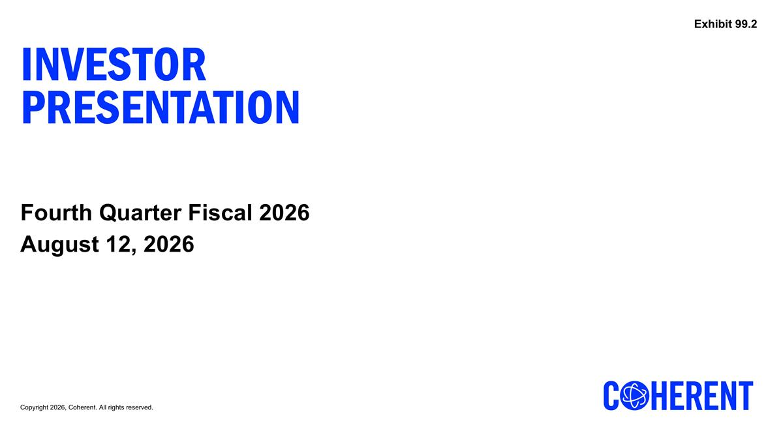
Fourth Quarter Fiscal 2026 August 12, 2026 Investor Presentation Exhibit 99.2

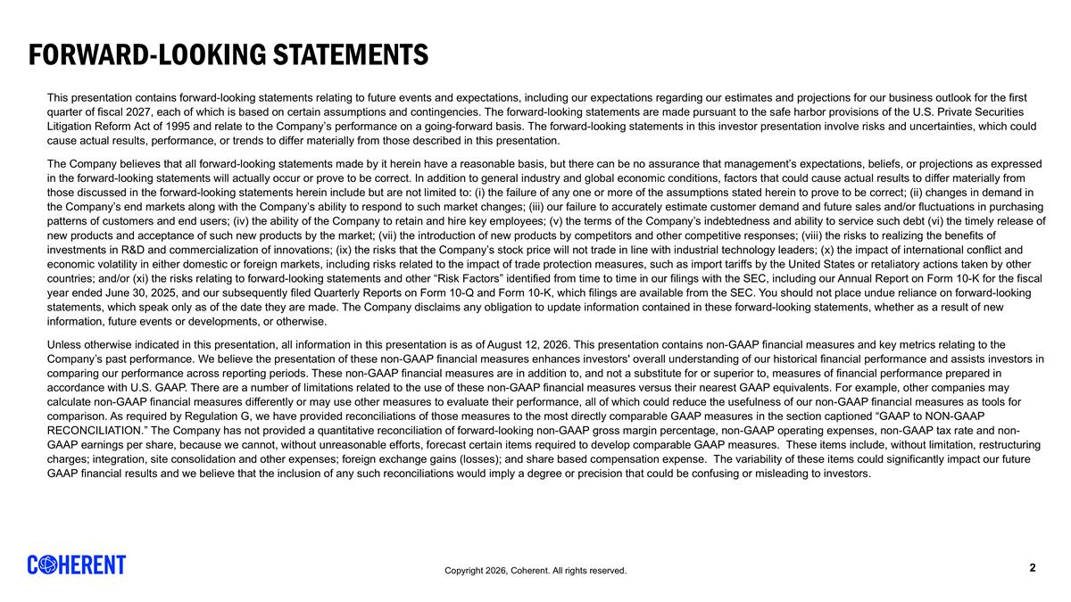
Forward-Looking Statements This presentation contains forward-looking statements relating to future events and expectations, including our expectations regarding our estimates and projections for our business outlook for the first quarter of fiscal 2027, each of which is based on certain assumptions and contingencies. The forward-looking statements are made pursuant to the safe harbor provisions of the U.S. Private Securities Litigation Reform Act of 1995 and relate to the Company’s performance on a going-forward basis. The forward-looking statements in this investor presentation involve risks and uncertainties, which could cause actual results, performance, or trends to differ materially from those described in this presentation. The Company believes that all forward-looking statements made by it herein have a reasonable basis, but there can be no assurance that management’s expectations, beliefs, or projections as expressed in the forward-looking statements will actually occur or prove to be correct. In addition to general industry and global economic conditions, factors that could cause actual results to differ materially from those discussed in the forward-looking statements herein include but are not limited to: (i) the failure of any one or more of the assumptions stated herein to prove to be correct; (ii) changes in demand in the Company’s end markets along with the Company’s ability to respond to such market changes; (iii) our failure to accurately estimate customer demand and future sales and/or fluctuations in purchasing patterns of customers and end users; (iv) the ability of the Company to retain and hire key employees; (v) the terms of the Company’s indebtedness and ability to service such debt (vi) the timely release of new products and acceptance of such new products by the market; (vii) the introduction of new products by competitors and other competitive responses; (viii) the risks to realizing the benefits of investments in R&D and commercialization of innovations; (ix) the risks that the Company’s stock price will not trade in line with industrial technology leaders; (x) the impact of international conflict and economic volatility in either domestic or foreign markets, including risks related to the impact of trade protection measures, such as import tariffs by the United States or retaliatory actions taken by other countries; and/or (xi) the risks relating to forward-looking statements and other “Risk Factors” identified from time to time in our filings with the SEC, including our Annual Report on Form 10-K for the fiscal year ended June 30, 2025, and our subsequently filed Quarterly Reports on Form 10-Q and Form 10-K, which filings are available from the SEC. You should not place undue reliance on forward-looking statements, which speak only as of the date they are made. The Company disclaims any obligation to update information contained in these forward-looking statements, whether as a result of new information, future events or developments, or otherwise. Unless otherwise indicated in this presentation, all information in this presentation is as of August 12, 2026. This presentation contains non-GAAP financial measures and key metrics relating to the Company’s past performance. We believe the presentation of these non-GAAP financial measures enhances investors' overall understanding of our historical financial performance and assists investors in comparing our performance across reporting periods. These non-GAAP financial measures are in addition to, and not a substitute for or superior to, measures of financial performance prepared in accordance with U.S. GAAP. There are a number of limitations related to the use of these non-GAAP financial measures versus their nearest GAAP equivalents. For example, other companies may calculate non-GAAP financial measures differently or may use other measures to evaluate their performance, all of which could reduce the usefulness of our non-GAAP financial measures as tools for comparison. As required by Regulation G, we have provided reconciliations of those measures to the most directly comparable GAAP measures in the section captioned “GAAP to NON-GAAP RECONCILIATION.” The Company has not provided a quantitative reconciliation of forward-looking non-GAAP gross margin percentage, non-GAAP operating expenses, non-GAAP tax rate and non-GAAP earnings per share, because we cannot, without unreasonable efforts, forecast certain items required to develop comparable GAAP measures. These items include, without limitation, restructuring charges; integration, site consolidation and other expenses; foreign exchange gains (losses); and share based compensation expense. The variability of these items could significantly impact our future GAAP financial results and we believe that the inclusion of any such reconciliations would imply a degree or precision that could be confusing or misleading to investors.

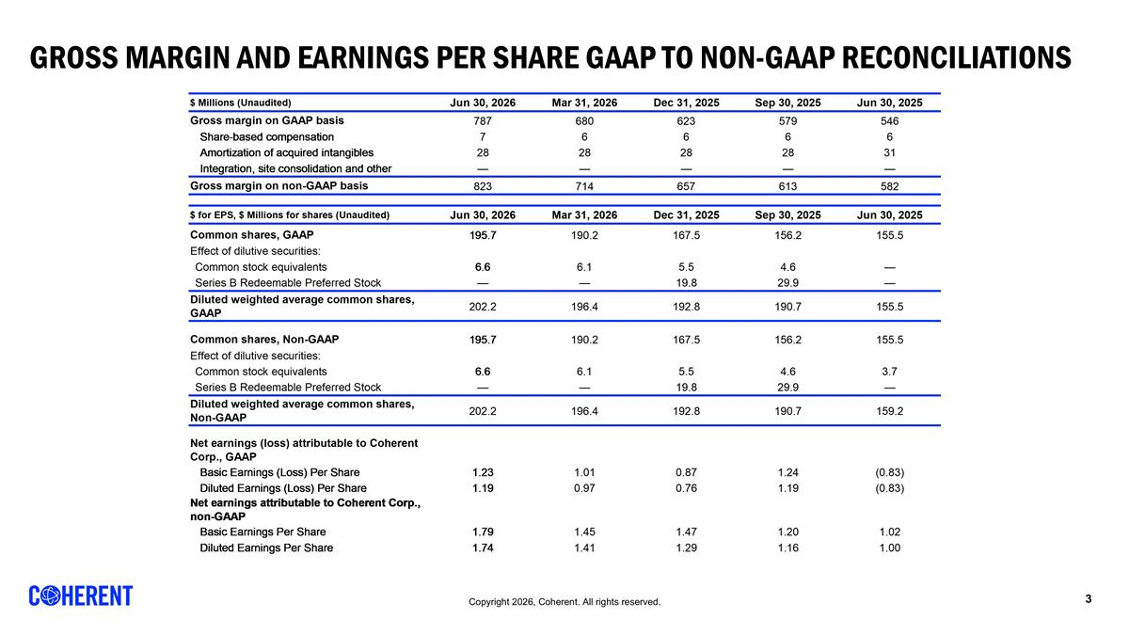
Gross MARGIN and earnings per share GAAP to Non-GAAP Reconciliations REVENUE BY SEGMENT [Data used for bar graph] $ Millions 45,838 45,930 46,022 46,112 46,203 Datacenter and Communications 1,018 1,090 1,208 1,362 1,615 0.79 0.70857315964859136 Industrial 511 491 478 444 431 0.21 Total 1,529 1,581 1,686 1,806 2,046 1 REVENUE BY MARKET [Data used for bar graph] $ Millions 45,838 45,930 46,022 46,112 46,203 Datacenter and Communications 1,018 1,090 1,208 1,362 1,615 0.79 Industrial 511 491 478 444 431 0.21 Total 1,529 1,581 1,686 1,806 2,046 1 REVENUE BY REGION [Data used for bar graph] $ Millions 45,382 45,473 45,565 45,657 45,747 North America 688 756 807 860 944 0.63 0.1 0.37 Europe 182 182 169 167 173 0.12 0.04 -0.05 Japan & Korea 155 167 165 187 177 0.12 -0.05 0.14000000000000001 China 154 173 170 184 161 0.11 rounded to foot -0.13 0.05 Other 30 36 37 37 43 0.03 0.16 0.43 Total 1,209 1,314 1,348 1,435 1,498 1 0.04 0.24 GROSS MARGIN RECONCILIATION $ Millions (Unaudited) 46,203 46,112 46,022 45,930 45,838 Gross margin on GAAP basis 787 680 623 579 546 Share-based compensation 7 6 6 6 6 Amortization of acquired intangibles 28 28 28 28 31 Fair value adjustment on acquired inventory 0 0 Start-up costs 0 0 Integration, site consolidation and other 0 0 0 0 0 Gross margin on non-GAAP basis 823 714 657 613 582 OPERATING EXPENSES RECONCILIATION $ Millions (Unaudited) 46,203 46,112 46,022 45,930 45,838 R&D on GAAP basis 216 186 166 155 156 Share-based compensation -8 -7 -7 -7 -6 Amortization of acquired intangibles 0 0 0 0 0 Start-up costs 0 0 Integration, site consolidation and other R&D on non-GAAP basis 208 178 159 148 150 SG&A on GAAP basis 266 268 259 252 245 Share-based compensation -39 -37 -32 -32 -33 Amortization of acquired intangibles -42 -42 -43 -42 -41 Financing fees 0 0 -1 0 0 Integration, site consolidation and other -17 -19 -21 -23 -14 SG&A on non-GAAP basis 169 170 162 156 157 Restructuring on GAAP basis 6 34 4 19 54 Restructuring -6 -34 -4 -19 -54 Restructuring on non-GAAP basis 0 0 0 0 0 Impairment of assets held-for-sale on GAAP basis 44 0 11 9 85 Impairment of assets held-for-sale -44 0 -11 -9 -85 Impairment of assets held-for-sale on non-GAAP basis 0 0 0 0 0 Gain on sale of business on GAAP basis 0 -9 0 -,115 0 Gain on sale of business 0 9 0 115 0 Gain on sale of business on non-GAAP basis 0 0 0 0 0 INCOME FROM OPERATIONS RECONCILIATION $ Millions (Unaudited) 46,203 46,112 46,022 45,930 45,838 Op. income on GAAP basis 254 201 184 259 6 Share-based compensation 54 51 45 45 44 Fair value adjustment on acquired inventory 0 0 0 0 0 Amortization of acquired intangibles 70 71 71 70 72 Restructuring charges 6 34 4 19 54 Financing fees 0 0 1 0 0 Impairment of assets held-for-sale 44 0 11 9 85 Gain on sale of business 0 -9 0 -,115 0 Integration, site consolidation and other 18 19 21 22 14 Op. income on non-GAAP basis 446 366 336 309 275 Non-GAAP Op. Margin Percentage 0.218 0.20300000000000001 0.19899999999999998 0.19500000000000001 0.18 NET EARNINGS RECONCILIATION $ Millions (Unaudited) 46,203 46,112 46,022 45,930 45,838 Net earnings (loss) attributable to Coherent Corp. on GAAP basis 241 191 147 226 -96 Share-based compensation 54 51 45 45 44 Amortization of acquired intangibles 70 71 71 70 72 Fair value adjustment on acquired inventory 0 0 Start-up costs 0 0 Foreign currency exch. (gains) losses -4 1 -2 -1 37 Restructuring charges 6 34 4 19 54 Impairment of assets held-for-sale 44 0 11 9 85 Gain on sale of business 0 -9 0 -,115 0 Integration, site consolidation and other 18 19 21 22 14 Gain on sale of investment -38 -14 -15 -7 0 Financing fees 0 0 1 12 0 Non-controlling interest impact of non-GAAP items 0 -6 0 0 0 Tax impact of non-GAAP measures -39 -61 -33 -60 -18 Net earnings attributable to Coherent Corp. on non-GAAP basis 351 276 248 221 192 GROSS MARGIN AND EARNINGS PER COMMON SHARE $ Millions (Unaudited) 46,203 46,112 46,022 45,930 45,838 Gross margin on GAAP basis 787 680 623 579 546 Share-based compensation 7 6 6 6 6 Amortization of acquired intangibles 28 28 28 28 31 Integration, site consolidation and other 0 0 0 0 0 Gross margin on non-GAAP basis 823 714 657 613 582 $ for EPS, $ Millions for shares (Unaudited) 46,203 46,112 46,022 45,930 45,838 Common shares, GAAP 195.7 190.2 167.5 156.19999999999999 155.5 Effect of dilutive securities: Common stock equivalents 6.6 6.1 5.5 4.5999999999999996 0 Series B Redeemable Preferred Stock 0 0 19.8 29.9 0 Diluted weighted average common shares, GAAP 202.2 196.4 192.8 190.7 155.5 Common shares, Non-GAAP 195.7 190.2 167.5 156.19999999999999 155.5 Effect of dilutive securities: Common stock equivalents 6.6 6.1 5.5 4.5999999999999996 3.7 Series B Redeemable Preferred Stock 0 0 19.8 29.9 0 Diluted weighted average common shares, Non-GAAP 202.2 196.4 192.8 190.7 159.19999999999999 Net earnings (loss) attributable to Coherent Corp., GAAP Basic Earnings (Loss) Per Share 1.23 1.01 0.87 1.24 -0.83 Diluted Earnings (Loss) Per Share 1.19 0.97 0.76 1.19 -0.83 Net earnings attributable to Coherent Corp., non-GAAP Basic Earnings Per Share 1.79 1.45 1.47 1.2 1.02 Diluted Earnings Per Share 1.74 1.41 1.29 1.1599999999999999 1 NET EARNINGS, GAAP, AND ADJUSTED EBITDA RECONCILIATION $ Millions (Unaudited) 46,203 46,112 46,022 45,930 45,838 Net earnings (loss) on GAAP basis 236 182 144 225 -98 Income taxes (benefit) 42 3 24 -8 35 Depreciation and amortization 141 133 126 122 135 Interest expense 41 45 46 59 55 Interest income -19 -11 -10 -10 -11 EBITDA 441 351 330 389 116 EBITDA margin 0.21600000000000003 0.19399999999999998 0.19600000000000001 0.24600000000000002 7.5999999999999998 Prelim. fair value adj. on acquired inv. 0 0 Share-based compensation 45 51 45 45 44 Foreign currency exch. (gains) losses -2 1 -2 -1 37 Start-up costs 0 0 Restructuring charges 6 34 4 19 54 Impairment of assets held-for-sale 44 0 11 9 85 Gain on sale of business 0 -9 0 -,115 0 Financing fees -38 -14 -14 6 0 Integration, site consolidation and other 18 19 21 22 14 Adjusted EBITDA 521 433 395 347 350 Less: adjusted EBITDA attributable to noncontrolling interests 3 3 1 0 1 Adjusted EBITDA attributable to Coherent Corp. 524 436 396 373 351 Adjusted EBITDA margin attributable to Coherent Corp. 0.25600000000000001 0.24100000000000002 0.23500000000000001 0.23600000000000002 0.22899999999999998 NET EARNINGS RECONCILIATION, GAAP to non-GAAP $ Millions (Unaudited) 46,203 Net earnings attributable to Coherent Corp. on GAAP basis 241 Share-based compensation 54 Amortization of acquired intangibles 70 Foreign currency exch. (gains) losses -4 Restructuring charges 6 Impairment of assets held-for-sale 44 Gain on sale of business 0 Integration, site consolidation and other 18 Gain on sale of investment -38 Financing fees 0 Non-controlling interest impact of non-GAAP items 0 Tax impact of non-GAAP measures -39 Net earnings attributable to Coherent Corp. on non-GAAP basis 351 Basic weighted average shares, GAAP 195.7 Diluted weighted average shares, GAAP 202.2 Diluted weighted average shares, non-GAAP 202.2 Net diluted earnings per share attributable to Coherent Corp., GAAP $1.19 Net earnings per share attributable to Coherent Corp., non-GAAP $1.74 REVENUE BY SEGMENT [Data used for bar graph] $ Millions 45,838 45,930 46,022 46,112 46,203 Datacenter and Communications 1,018 1,090 1,208 1,362 1,615 0.79 0.70857315964859136 Industrial 511 491 478 444 431 0.21 Total 1,529 1,581 1,686 1,806 2,046 1 REVENUE BY MARKET [Data used for bar graph] $ Millions 45,838 45,930 46,022 46,112 46,203 Datacenter and Communications 1,018 1,090 1,208 1,362 1,615 0.79 Industrial 511 491 478 444 431 0.21 Total 1,529 1,581 1,686 1,806 2,046 1 REVENUE BY REGION [Data used for bar graph] $ Millions 45,382 45,473 45,565 45,657 45,747 North America 688 756 807 860 944 0.63 0.1 0.37 Europe 182 182 169 167 173 0.12 0.04 -0.05 Japan & Korea 155 167 165 187 177 0.12 -0.05 0.14000000000000001 China 154 173 170 184 161 0.11 rounded to foot -0.13 0.05 Other 30 36 37 37 43 0.03 0.16 0.43 Total 1,209 1,314 1,348 1,435 1,498 1 0.04 0.24 GROSS MARGIN RECONCILIATION $ Millions (Unaudited) 46,203 46,112 46,022 45,930 45,838 Gross margin on GAAP basis 787 680 623 579 546 Share-based compensation 7 6 6 6 6 Amortization of acquired intangibles 28 28 28 28 31 Fair value adjustment on acquired inventory 0 0 Start-up costs 0 0 Integration, site consolidation and other 0 0 0 0 0 Gross margin on non-GAAP basis 823 714 657 613 582 OPERATING EXPENSES RECONCILIATION $ Millions (Unaudited) 46,203 46,112 46,022 45,930 45,838 R&D on GAAP basis 216 186 166 155 156 Share-based compensation -8 -7 -7 -7 -6 Amortization of acquired intangibles 0 0 0 0 0 Start-up costs 0 0 Integration, site consolidation and other R&D on non-GAAP basis 208 178 159 148 150 SG&A on GAAP basis 266 268 259 252 245 Share-based compensation -39 -37 -32 -32 -33 Amortization of acquired intangibles -42 -42 -43 -42 -41 Financing fees 0 0 -1 0 0 Integration, site consolidation and other -17 -19 -21 -23 -14 SG&A on non-GAAP basis 169 170 162 156 157 Restructuring on GAAP basis 6 34 4 19 54 Restructuring -6 -34 -4 -19 -54 Restructuring on non-GAAP basis 0 0 0 0 0 Impairment of assets held-for-sale on GAAP basis 44 0 11 9 85 Impairment of assets held-for-sale -44 0 -11 -9 -85 Impairment of assets held-for-sale on non-GAAP basis 0 0 0 0 0 Gain on sale of business on GAAP basis 0 -9 0 -,115 0 Gain on sale of business 0 9 0 115 0 Gain on sale of business on non-GAAP basis 0 0 0 0 0 INCOME FROM OPERATIONS RECONCILIATION $ Millions (Unaudited) 46,203 46,112 46,022 45,930 45,838 Op. income on GAAP basis 254 201 184 259 6 Share-based compensation 54 51 45 45 44 Fair value adjustment on acquired inventory 0 0 0 0 0 Amortization of acquired intangibles 70 71 71 70 72 Restructuring charges 6 34 4 19 54 Financing fees 0 0 1 0 0 Impairment of assets held-for-sale 44 0 11 9 85 Gain on sale of business 0 -9 0 -,115 0 Integration, site consolidation and other 18 19 21 22 14 Op. income on non-GAAP basis 446 366 336 309 275 Non-GAAP Op. Margin Percentage 0.218 0.20300000000000001 0.19899999999999998 0.19500000000000001 0.18 NET EARNINGS RECONCILIATION $ Millions (Unaudited) 46,203 46,112 46,022 45,930 45,838 Net earnings (loss) attributable to Coherent Corp. on GAAP basis 241 191 147 226 -96 Share-based compensation 54 51 45 45 44 Amortization of acquired intangibles 70 71 71 70 72 Fair value adjustment on acquired inventory 0 0 Start-up costs 0 0 Foreign currency exch. (gains) losses -4 1 -2 -1 37 Restructuring charges 6 34 4 19 54 Impairment of assets held-for-sale 44 0 11 9 85 Gain on sale of business 0 -9 0 -,115 0 Integration, site consolidation and other 18 19 21 22 14 Gain on sale of investment -38 -14 -15 -7 0 Financing fees 0 0 1 12 0 Non-controlling interest impact of non-GAAP items 0 -6 0 0 0 Tax impact of non-GAAP measures -39 -61 -33 -60 -18 Net earnings attributable to Coherent Corp. on non-GAAP basis 351 276 248 221 192 GROSS MARGIN AND EARNINGS PER COMMON SHARE $ Millions (Unaudited) 46,203 46,112 46,022 45,930 45,838 Gross margin on GAAP basis 787 680 623 579 546 Share-based compensation 7 6 6 6 6 Amortization of acquired intangibles 28 28 28 28 31 Integration, site consolidation and other 0 0 0 0 0 Gross margin on non-GAAP basis 823 714 657 613 582 $ for EPS, $ Millions for shares (Unaudited) 46,203 46,112 46,022 45,930 45,838 Common shares, GAAP 195.7 190.2 167.5 156.19999999999999 155.5 Effect of dilutive securities: Common stock equivalents 6.6 6.1 5.5 4.5999999999999996 0 Series B Redeemable Preferred Stock 0 0 19.8 29.9 0 Diluted weighted average common shares, GAAP 202.2 196.4 192.8 190.7 155.5 Common shares, Non-GAAP 195.7 190.2 167.5 156.19999999999999 155.5 Effect of dilutive securities: Common stock equivalents 6.6 6.1 5.5 4.5999999999999996 3.7 Series B Redeemable Preferred Stock 0 0 19.8 29.9 0 Diluted weighted average common shares, Non-GAAP 202.2 196.4 192.8 190.7 159.19999999999999 Net earnings (loss) attributable to Coherent Corp., GAAP Basic Earnings (Loss) Per Share 1.23 1.01 0.87 1.24 -0.83 Diluted Earnings (Loss) Per Share 1.19 0.97 0.76 1.19 -0.83 Net earnings attributable to Coherent Corp., non-GAAP Basic Earnings Per Share 1.79 1.45 1.47 1.2 1.02 Diluted Earnings Per Share 1.74 1.41 1.29 1.1599999999999999 1 NET EARNINGS, GAAP, AND ADJUSTED EBITDA RECONCILIATION $ Millions (Unaudited) 46,203 46,112 46,022 45,930 45,838 Net earnings (loss) on GAAP basis 236 182 144 225 -98 Income taxes (benefit) 42 3 24 -8 35 Depreciation and amortization 141 133 126 122 135 Interest expense 41 45 46 59 55 Interest income -19 -11 -10 -10 -11 EBITDA 441 351 330 389 116 EBITDA margin 0.21600000000000003 0.19399999999999998 0.19600000000000001 0.24600000000000002 7.5999999999999998 Prelim. fair value adj. on acquired inv. 0 0 Share-based compensation 45 51 45 45 44 Foreign currency exch. (gains) losses -2 1 -2 -1 37 Start-up costs 0 0 Restructuring charges 6 34 4 19 54 Impairment of assets held-for-sale 44 0 11 9 85 Gain on sale of business 0 -9 0 -,115 0 Financing fees -38 -14 -14 6 0 Integration, site consolidation and other 18 19 21 22 14 Adjusted EBITDA 521 433 395 347 350 Less: adjusted EBITDA attributable to noncontrolling interests 3 3 1 0 1 Adjusted EBITDA attributable to Coherent Corp. 524 436 396 373 351 Adjusted EBITDA margin attributable to Coherent Corp. 0.25600000000000001 0.24100000000000002 0.23500000000000001 0.23600000000000002 0.22899999999999998 NET EARNINGS RECONCILIATION, GAAP to non-GAAP $ Millions (Unaudited) 46,203 Net earnings attributable to Coherent Corp. on GAAP basis 241 Share-based compensation 54 Amortization of acquired intangibles 70 Foreign currency exch. (gains) losses -4 Restructuring charges 6 Impairment of assets held-for-sale 44 Gain on sale of business 0 Integration, site consolidation and other 18 Gain on sale of investment -38 Financing fees 0 Non-controlling interest impact of non-GAAP items 0 Tax impact of non-GAAP measures -39 Net earnings attributable to Coherent Corp. on non-GAAP basis 351 Basic weighted average shares, GAAP 195.7 Diluted weighted average shares, GAAP 202.2 Diluted weighted average shares, non-GAAP 202.2 Net diluted earnings per share attributable to Coherent Corp., GAAP $1.19 Net earnings per share attributable to Coherent Corp., non-GAAP $1.74

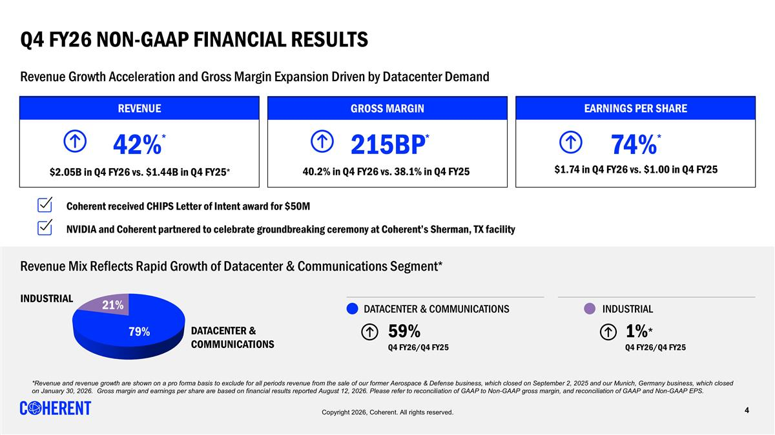
Q4 FY26 NON-gaap Financial Results 59% Q4 FY26/Q4 FY25 DATACENTER & COMMUNICATIONS DATACENTER & COMMUNICATIONS INDUSTRIAL EARNINGS PER SHARE 74%* $1.74 in Q4 FY26 vs. $1.00 in Q4 FY25 GROSS MARGIN 40.2% in Q4 FY26 vs. 38.1% in Q4 FY25 215BP* REVENUE 42%* $2.05B in Q4 FY26 vs. $1.44B in Q4 FY25* Coherent received CHIPS Letter of Intent award for $50M Revenue Growth Acceleration and Gross Margin Expansion Driven by Datacenter Demand Copyright 2026, Coherent. All rights reserved. Revenue Mix Reflects Rapid Growth of Datacenter & Communications Segment* INDUSTRIAL 1%* Q4 FY26/Q4 FY25 NVIDIA and Coherent partnered to celebrate groundbreaking ceremony at Coherent’s Sherman, TX facility *Revenue and revenue growth are shown on a pro forma basis to exclude for all periods revenue from the sale of our former Aerospace & Defense business, which closed on September 2, 2025 and our Munich, Germany business, which closed on January 30, 2026. Gross margin and earnings per share are based on financial results reported August 12, 2026. Please refer to reconciliation of GAAP to Non-GAAP gross margin, and reconciliation of GAAP and Non-GAAP EPS.

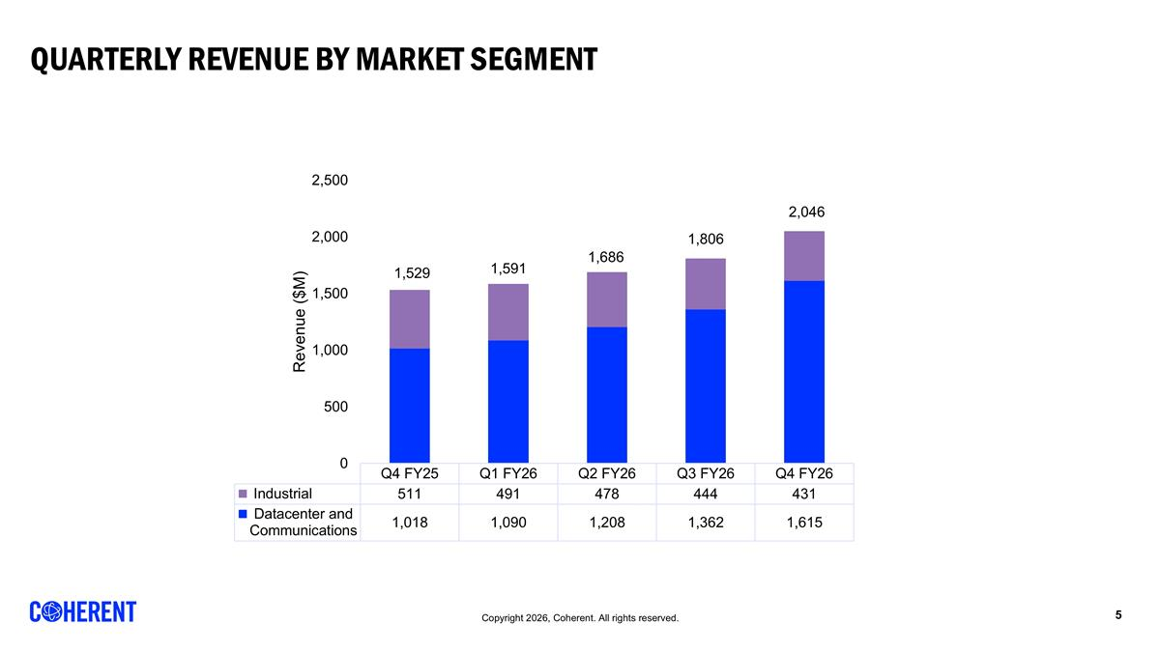
QUARTERLY REVENUE BY Market SEGMENT

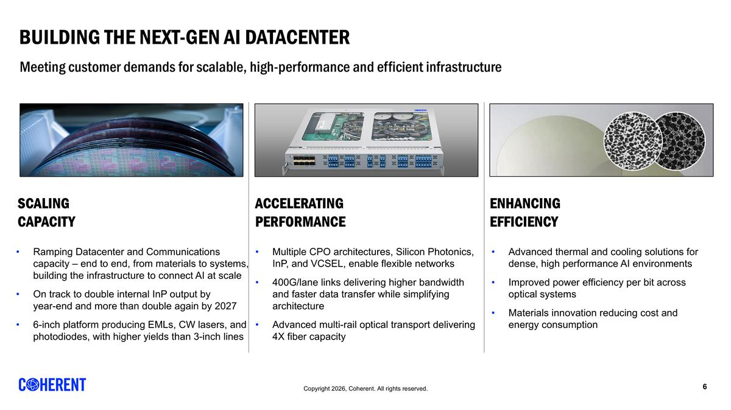
Building the Next-Gen AI Datacenter SCALING CAPACITY ACCELERATING PERFORMANCE ENHANCING EFFICIENCY Advanced thermal and cooling solutions for dense, high performance AI environments Improved power efficiency per bit across optical systems Materials innovation reducing cost and energy consumption Ramping Datacenter and Communications capacity – end to end, from materials to systems, building the infrastructure to connect AI at scale On track to double internal InP output by year-end and more than double again by 2027 6-inch platform producing EMLs, CW lasers, and photodiodes, with higher yields than 3-inch lines Multiple CPO architectures, Silicon Photonics, InP, and VCSEL, enable flexible networks 400G/lane links delivering higher bandwidth and faster data transfer while simplifying architecture Advanced multi-rail optical transport delivering 4X fiber capacity Meeting customer demands for scalable, high-performance and efficient infrastructure

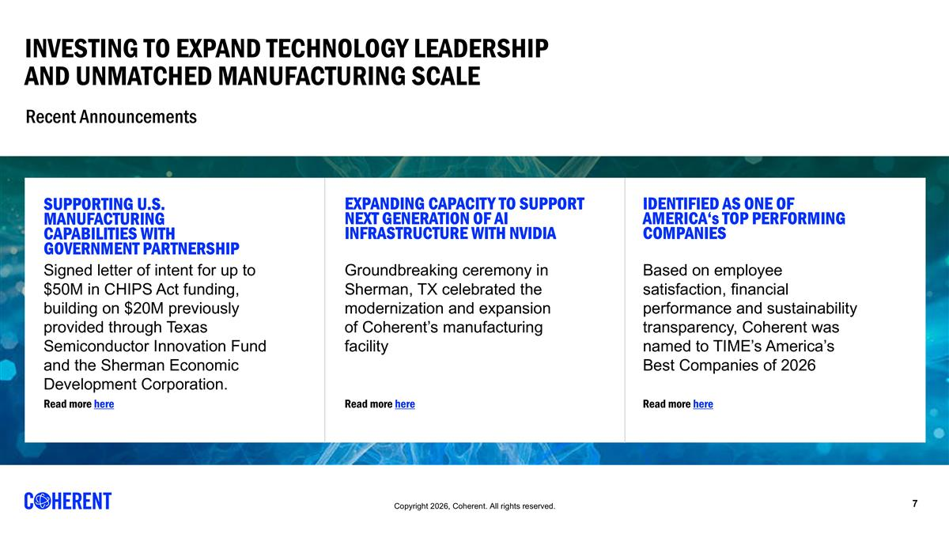
Investing to EXPAND Technology Leadership and Unmatched Manufacturing Scale SUPPORTING U.S. MANUFACTURING CAPABILITIES WITH GOVERNMENT PARTNERSHIP EXPANDING CAPACITY TO SUPPORT NEXT GENERATION OF AI INFRASTRUCTURE WITH NVIDIA IDENTIFIED AS ONE OF AMERICA‘s TOP PERFORMING COMPANIES Signed letter of intent for up to $50M in CHIPS Act funding, building on $20M previously provided through Texas Semiconductor Innovation Fund and the Sherman Economic Development Corporation. Groundbreaking ceremony in Sherman, TX celebrated the modernization and expansion of Coherent’s manufacturing facility Based on employee satisfaction, financial performance and sustainability transparency, Coherent was named to TIME’s America’s Best Companies of 2026 Read more here Read more here Read more here Recent Announcements

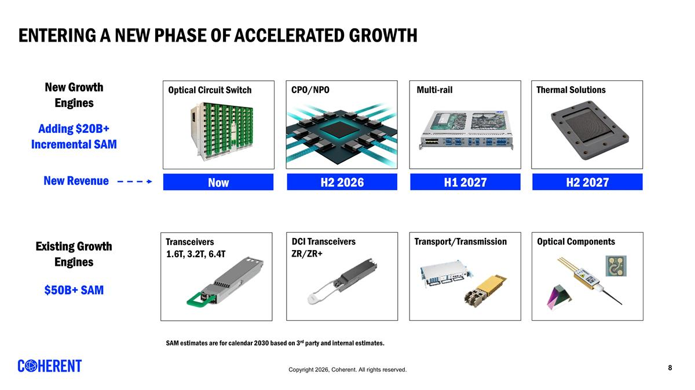
Entering a new phase of accelerated growth Existing Growth Engines New Growth Engines Transceivers 1.6T, 3.2T, 6.4T DCI Transceivers ZR/ZR+ Transport/Transmission Optical Circuit Switch Optical Components Multi-rail Adding $20B+ Incremental SAM $50B+ SAM SAM estimates are for calendar 2030 based on 3rd party and internal estimates. Now H1 2027 New Revenue Thermal Solutions H2 2027 CPO/NPO H2 2026

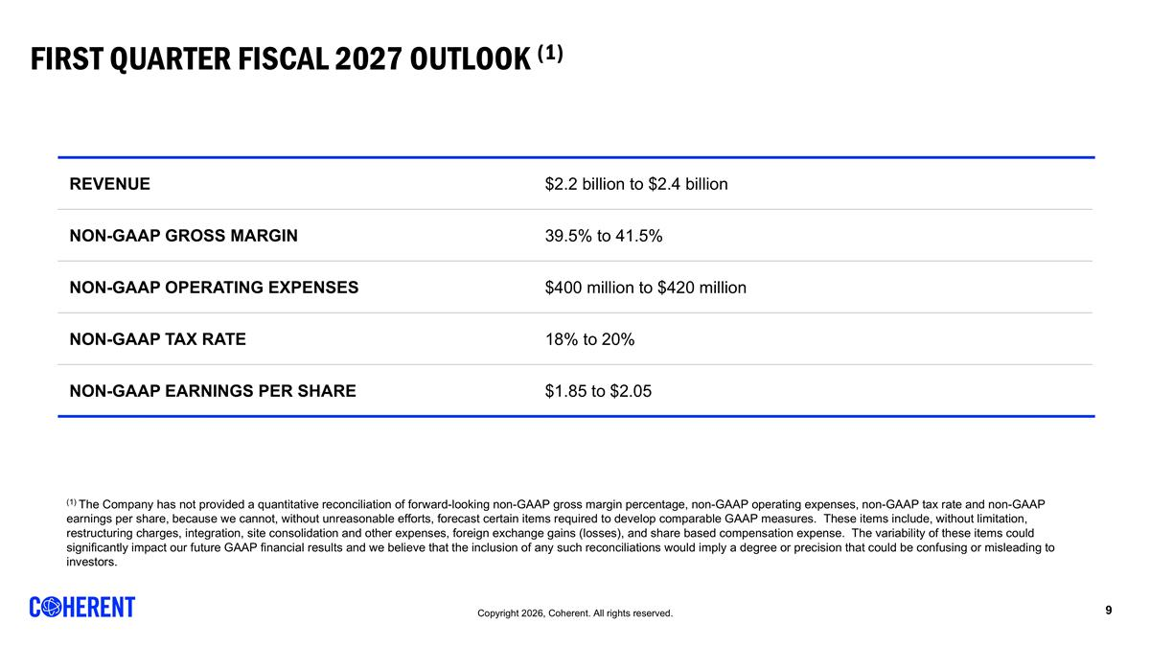
First quarter fiscal 2027 Outlook (1) REVENUE $2.2 billion to $2.4 billion NON-GAAP GROSS MARGIN 39.5% to 41.5% NON-GAAP OPERATING EXPENSES $400 million to $420 million NON-GAAP TAX RATE 18% to 20% NON-GAAP EARNINGS PER SHARE $1.85 to $2.05 (1) The Company has not provided a quantitative reconciliation of forward-looking non-GAAP gross margin percentage, non-GAAP operating expenses, non-GAAP tax rate and non-GAAP earnings per share, because we cannot, without unreasonable efforts, forecast certain items required to develop comparable GAAP measures. These items include, without limitation, restructuring charges, integration, site consolidation and other expenses, foreign exchange gains (losses), and share based compensation expense. The variability of these items could significantly impact our future GAAP financial results and we believe that the inclusion of any such reconciliations would imply a degree or precision that could be confusing or misleading to investors.

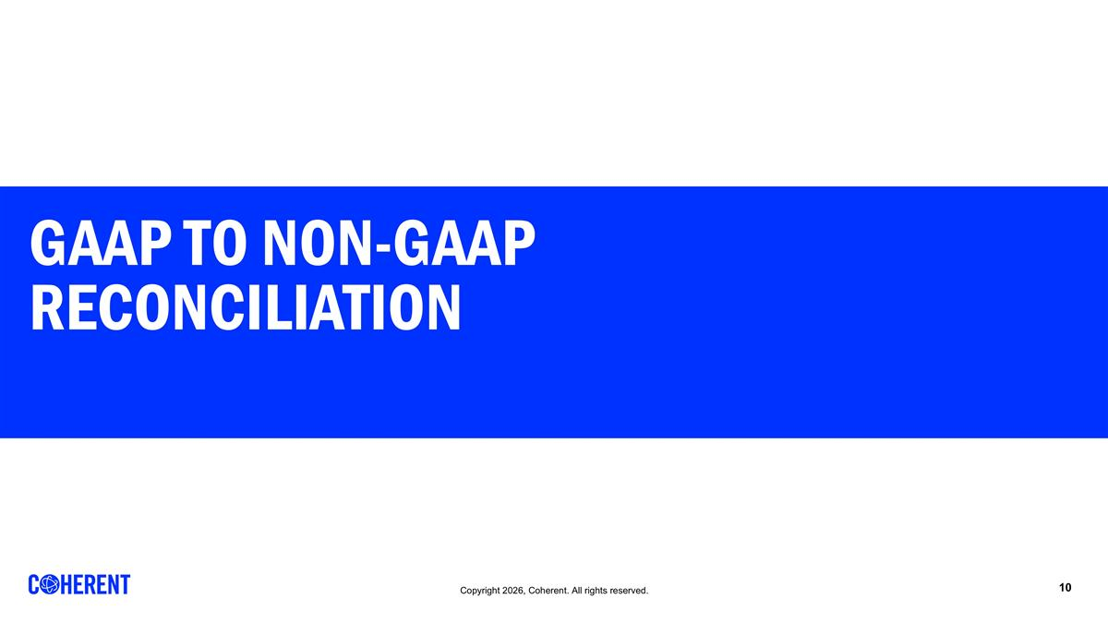
Gaap to Non-Gaap Reconciliation

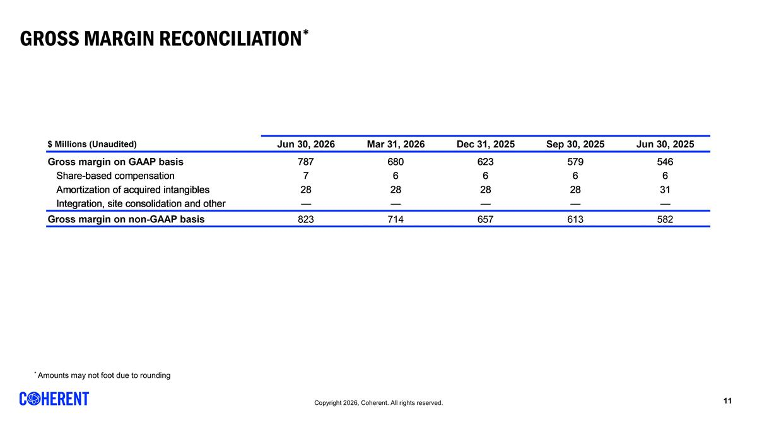
Gross MARGIN Reconciliation* * Amounts may not foot due to rounding REVENUE BY SEGMENT [Data used for bar graph] $ Millions 45,838 45,930 46,022 46,112 46,203 Datacenter and Communications 1,018 1,090 1,208 1,362 1,615 0.79 0.70857315964859136 Industrial 511 491 478 444 431 0.21 Total 1,529 1,581 1,686 1,806 2,046 1 REVENUE BY MARKET [Data used for bar graph] $ Millions 45,838 45,930 46,022 46,112 46,203 Datacenter and Communications 1,018 1,090 1,208 1,362 1,615 0.79 Industrial 511 491 478 444 431 0.21 Total 1,529 1,581 1,686 1,806 2,046 1 REVENUE BY REGION [Data used for bar graph] $ Millions 45,382 45,473 45,565 45,657 45,747 North America 688 756 807 860 944 0.63 0.1 0.37 Europe 182 182 169 167 173 0.12 0.04 -0.05 Japan & Korea 155 167 165 187 177 0.12 -0.05 0.14000000000000001 China 154 173 170 184 161 0.11 rounded to foot -0.13 0.05 Other 30 36 37 37 43 0.03 0.16 0.43 Total 1,209 1,314 1,348 1,435 1,498 1 0.04 0.24 GROSS MARGIN RECONCILIATION $ Millions (Unaudited) 46,203 46,112 46,022 45,930 45,838 Gross margin on GAAP basis 787 680 623 579 546 Share-based compensation 7 6 6 6 6 Amortization of acquired intangibles 28 28 28 28 31 Fair value adjustment on acquired inventory 0 0 Start-up costs 0 0 Integration, site consolidation and other 0 0 0 0 0 Gross margin on non-GAAP basis 823 714 657 613 582 OPERATING EXPENSES RECONCILIATION $ Millions (Unaudited) 46,203 46,112 46,022 45,930 45,838 R&D on GAAP basis 216 186 166 155 156 Share-based compensation -8 -7 -7 -7 -6 Amortization of acquired intangibles 0 0 0 0 0 Start-up costs 0 0 Integration, site consolidation and other R&D on non-GAAP basis 208 178 159 148 150 SG&A on GAAP basis 266 268 259 252 245 Share-based compensation -39 -37 -32 -32 -33 Amortization of acquired intangibles -42 -42 -43 -42 -41 Financing fees 0 0 -1 0 0 Integration, site consolidation and other -17 -19 -21 -23 -14 SG&A on non-GAAP basis 169 170 162 156 157 Restructuring on GAAP basis 6 34 4 19 54 Restructuring -6 -34 -4 -19 -54 Restructuring on non-GAAP basis 0 0 0 0 0 Impairment of assets held-for-sale on GAAP basis 44 0 11 9 85 Impairment of assets held-for-sale -44 0 -11 -9 -85 Impairment of assets held-for-sale on non-GAAP basis 0 0 0 0 0 Gain on sale of business on GAAP basis 0 -9 0 -,115 0 Gain on sale of business 0 9 0 115 0 Gain on sale of business on non-GAAP basis 0 0 0 0 0 INCOME FROM OPERATIONS RECONCILIATION $ Millions (Unaudited) 46,203 46,112 46,022 45,930 45,838 Op. income on GAAP basis 254 201 184 259 6 Share-based compensation 54 51 45 45 44 Fair value adjustment on acquired inventory 0 0 0 0 0 Amortization of acquired intangibles 70 71 71 70 72 Restructuring charges 6 34 4 19 54 Financing fees 0 0 1 0 0 Impairment of assets held-for-sale 44 0 11 9 85 Gain on sale of business 0 -9 0 -,115 0 Integration, site consolidation and other 18 19 21 22 14 Op. income on non-GAAP basis 446 366 336 309 275 Non-GAAP Op. Margin Percentage 0.218 0.20300000000000001 0.19899999999999998 0.19500000000000001 0.18 NET EARNINGS RECONCILIATION $ Millions (Unaudited) 46,203 46,112 46,022 45,930 45,838 Net earnings (loss) attributable to Coherent Corp. on GAAP basis 241 191 147 226 -96 Share-based compensation 54 51 45 45 44 Amortization of acquired intangibles 70 71 71 70 72 Fair value adjustment on acquired inventory 0 0 Start-up costs 0 0 Foreign currency exch. (gains) losses -4 1 -2 -1 37 Restructuring charges 6 34 4 19 54 Impairment of assets held-for-sale 44 0 11 9 85 Gain on sale of business 0 -9 0 -,115 0 Integration, site consolidation and other 18 19 21 22 14 Gain on sale of investment -38 -14 -15 -7 0 Financing fees 0 0 1 12 0 Non-controlling interest impact of non-GAAP items 0 -6 0 0 0 Tax impact of non-GAAP measures -39 -61 -33 -60 -18 Net earnings attributable to Coherent Corp. on non-GAAP basis 351 276 248 221 192 GROSS MARGIN AND EARNINGS PER COMMON SHARE $ Millions (Unaudited) 46,203 46,112 46,022 45,930 45,838 Gross margin on GAAP basis 787 680 623 579 546 Share-based compensation 7 6 6 6 6 Amortization of acquired intangibles 28 28 28 28 31 Integration, site consolidation and other 0 0 0 0 0 Gross margin on non-GAAP basis 823 714 657 613 582 $ for EPS, $ Millions for shares (Unaudited) 46,203 46,112 46,022 45,930 45,838 Common shares, GAAP 195.7 190.2 167.5 156.19999999999999 155.5 Effect of dilutive securities: Common stock equivalents 6.6 6.1 5.5 4.5999999999999996 0 Series B Redeemable Preferred Stock 0 0 19.8 29.9 0 Diluted weighted average common shares, GAAP 202.2 196.4 192.8 190.7 155.5 Common shares, Non-GAAP 195.7 190.2 167.5 156.19999999999999 155.5 Effect of dilutive securities: Common stock equivalents 6.6 6.1 5.5 4.5999999999999996 3.7 Series B Redeemable Preferred Stock 0 0 19.8 29.9 0 Diluted weighted average common shares, Non-GAAP 202.2 196.4 192.8 190.7 159.19999999999999 Net earnings (loss) attributable to Coherent Corp., GAAP Basic Earnings (Loss) Per Share 1.23 1.01 0.87 1.24 -0.83 Diluted Earnings (Loss) Per Share 1.19 0.97 0.76 1.19 -0.83 Net earnings attributable to Coherent Corp., non-GAAP Basic Earnings Per Share 1.79 1.45 1.47 1.2 1.02 Diluted Earnings Per Share 1.74 1.41 1.29 1.1599999999999999 1 NET EARNINGS, GAAP, AND ADJUSTED EBITDA RECONCILIATION $ Millions (Unaudited) 46,203 46,112 46,022 45,930 45,838 Net earnings (loss) on GAAP basis 236 182 144 225 -98 Income taxes (benefit) 42 3 24 -8 35 Depreciation and amortization 141 133 126 122 135 Interest expense 41 45 46 59 55 Interest income -19 -11 -10 -10 -11 EBITDA 441 351 330 389 116 EBITDA margin 0.21600000000000003 0.19399999999999998 0.19600000000000001 0.24600000000000002 7.5999999999999998 Prelim. fair value adj. on acquired inv. 0 0 Share-based compensation 45 51 45 45 44 Foreign currency exch. (gains) losses -2 1 -2 -1 37 Start-up costs 0 0 Restructuring charges 6 34 4 19 54 Impairment of assets held-for-sale 44 0 11 9 85 Gain on sale of business 0 -9 0 -,115 0 Financing fees -38 -14 -14 6 0 Integration, site consolidation and other 18 19 21 22 14 Adjusted EBITDA 521 433 395 347 350 Less: adjusted EBITDA attributable to noncontrolling interests 3 3 1 0 1 Adjusted EBITDA attributable to Coherent Corp. 524 436 396 373 351 Adjusted EBITDA margin attributable to Coherent Corp. 0.25600000000000001 0.24100000000000002 0.23500000000000001 0.23600000000000002 0.22899999999999998 NET EARNINGS RECONCILIATION, GAAP to non-GAAP $ Millions (Unaudited) 46,203 Net earnings attributable to Coherent Corp. on GAAP basis 241 Share-based compensation 54 Amortization of acquired intangibles 70 Foreign currency exch. (gains) losses -4 Restructuring charges 6 Impairment of assets held-for-sale 44 Gain on sale of business 0 Integration, site consolidation and other 18 Gain on sale of investment -38 Financing fees 0 Non-controlling interest impact of non-GAAP items 0 Tax impact of non-GAAP measures -39 Net earnings attributable to Coherent Corp. on non-GAAP basis 351 Basic weighted average shares, GAAP 195.7 Diluted weighted average shares, GAAP 202.2 Diluted weighted average shares, non-GAAP 202.2 Net diluted earnings per share attributable to Coherent Corp., GAAP $1.19 Net earnings per share attributable to Coherent Corp., non-GAAP $1.74 REVENUE BY SEGMENT [Data used for bar graph] $ Millions 45,838 45,930 46,022 46,112 46,203 Datacenter and Communications 1,018 1,090 1,208 1,362 1,615 0.79 0.70857315964859136 Industrial 511 491 478 444 431 0.21 Total 1,529 1,581 1,686 1,806 2,046 1 REVENUE BY MARKET [Data used for bar graph] $ Millions 45,838 45,930 46,022 46,112 46,203 Datacenter and Communications 1,018 1,090 1,208 1,362 1,615 0.79 Industrial 511 491 478 444 431 0.21 Total 1,529 1,581 1,686 1,806 2,046 1 REVENUE BY REGION [Data used for bar graph] $ Millions 45,382 45,473 45,565 45,657 45,747 North America 688 756 807 860 944 0.63 0.1 0.37 Europe 182 182 169 167 173 0.12 0.04 -0.05 Japan & Korea 155 167 165 187 177 0.12 -0.05 0.14000000000000001 China 154 173 170 184 161 0.11 rounded to foot -0.13 0.05 Other 30 36 37 37 43 0.03 0.16 0.43 Total 1,209 1,314 1,348 1,435 1,498 1 0.04 0.24 GROSS MARGIN RECONCILIATION $ Millions (Unaudited) 46,203 46,112 46,022 45,930 45,838 Gross margin on GAAP basis 787 680 623 579 546 Share-based compensation 7 6 6 6 6 Amortization of acquired intangibles 28 28 28 28 31 Fair value adjustment on acquired inventory 0 0 Start-up costs 0 0 Integration, site consolidation and other 0 0 0 0 0 Gross margin on non-GAAP basis 823 714 657 613 582 OPERATING EXPENSES RECONCILIATION $ Millions (Unaudited) 46,203 46,112 46,022 45,930 45,838 R&D on GAAP basis 216 186 166 155 156 Share-based compensation -8 -7 -7 -7 -6 Amortization of acquired intangibles 0 0 0 0 0 Start-up costs 0 0 Integration, site consolidation and other R&D on non-GAAP basis 208 178 159 148 150 SG&A on GAAP basis 266 268 259 252 245 Share-based compensation -39 -37 -32 -32 -33 Amortization of acquired intangibles -42 -42 -43 -42 -41 Financing fees 0 0 -1 0 0 Integration, site consolidation and other -17 -19 -21 -23 -14 SG&A on non-GAAP basis 169 170 162 156 157 Restructuring on GAAP basis 6 34 4 19 54 Restructuring -6 -34 -4 -19 -54 Restructuring on non-GAAP basis 0 0 0 0 0 Impairment of assets held-for-sale on GAAP basis 44 0 11 9 85 Impairment of assets held-for-sale -44 0 -11 -9 -85 Impairment of assets held-for-sale on non-GAAP basis 0 0 0 0 0 Gain on sale of business on GAAP basis 0 -9 0 -,115 0 Gain on sale of business 0 9 0 115 0 Gain on sale of business on non-GAAP basis 0 0 0 0 0 INCOME FROM OPERATIONS RECONCILIATION $ Millions (Unaudited) 46,203 46,112 46,022 45,930 45,838 Op. income on GAAP basis 254 201 184 259 6 Share-based compensation 54 51 45 45 44 Fair value adjustment on acquired inventory 0 0 0 0 0 Amortization of acquired intangibles 70 71 71 70 72 Restructuring charges 6 34 4 19 54 Financing fees 0 0 1 0 0 Impairment of assets held-for-sale 44 0 11 9 85 Gain on sale of business 0 -9 0 -,115 0 Integration, site consolidation and other 18 19 21 22 14 Op. income on non-GAAP basis 446 366 336 309 275 Non-GAAP Op. Margin Percentage 0.218 0.20300000000000001 0.19899999999999998 0.19500000000000001 0.18 NET EARNINGS RECONCILIATION $ Millions (Unaudited) 46,203 46,112 46,022 45,930 45,838 Net earnings (loss) attributable to Coherent Corp. on GAAP basis 241 191 147 226 -96 Share-based compensation 54 51 45 45 44 Amortization of acquired intangibles 70 71 71 70 72 Fair value adjustment on acquired inventory 0 0 Start-up costs 0 0 Foreign currency exch. (gains) losses -4 1 -2 -1 37 Restructuring charges 6 34 4 19 54 Impairment of assets held-for-sale 44 0 11 9 85 Gain on sale of business 0 -9 0 -,115 0 Integration, site consolidation and other 18 19 21 22 14 Gain on sale of investment -38 -14 -15 -7 0 Financing fees 0 0 1 12 0 Non-controlling interest impact of non-GAAP items 0 -6 0 0 0 Tax impact of non-GAAP measures -39 -61 -33 -60 -18 Net earnings attributable to Coherent Corp. on non-GAAP basis 351 276 248 221 192 GROSS MARGIN AND EARNINGS PER COMMON SHARE $ Millions (Unaudited) 46,203 46,112 46,022 45,930 45,838 Gross margin on GAAP basis 787 680 623 579 546 Share-based compensation 7 6 6 6 6 Amortization of acquired intangibles 28 28 28 28 31 Integration, site consolidation and other 0 0 0 0 0 Gross margin on non-GAAP basis 823 714 657 613 582 $ for EPS, $ Millions for shares (Unaudited) 46,203 46,112 46,022 45,930 45,838 Common shares, GAAP 195.7 190.2 167.5 156.19999999999999 155.5 Effect of dilutive securities: Common stock equivalents 6.6 6.1 5.5 4.5999999999999996 0 Series B Redeemable Preferred Stock 0 0 19.8 29.9 0 Diluted weighted average common shares, GAAP 202.2 196.4 192.8 190.7 155.5 Common shares, Non-GAAP 195.7 190.2 167.5 156.19999999999999 155.5 Effect of dilutive securities: Common stock equivalents 6.6 6.1 5.5 4.5999999999999996 3.7 Series B Redeemable Preferred Stock 0 0 19.8 29.9 0 Diluted weighted average common shares, Non-GAAP 202.2 196.4 192.8 190.7 159.19999999999999 Net earnings (loss) attributable to Coherent Corp., GAAP Basic Earnings (Loss) Per Share 1.23 1.01 0.87 1.24 -0.83 Diluted Earnings (Loss) Per Share 1.19 0.97 0.76 1.19 -0.83 Net earnings attributable to Coherent Corp., non-GAAP Basic Earnings Per Share 1.79 1.45 1.47 1.2 1.02 Diluted Earnings Per Share 1.74 1.41 1.29 1.1599999999999999 1 NET EARNINGS, GAAP, AND ADJUSTED EBITDA RECONCILIATION $ Millions (Unaudited) 46,203 46,112 46,022 45,930 45,838 Net earnings (loss) on GAAP basis 236 182 144 225 -98 Income taxes (benefit) 42 3 24 -8 35 Depreciation and amortization 141 133 126 122 135 Interest expense 41 45 46 59 55 Interest income -19 -11 -10 -10 -11 EBITDA 441 351 330 389 116 EBITDA margin 0.21600000000000003 0.19399999999999998 0.19600000000000001 0.24600000000000002 7.5999999999999998 Prelim. fair value adj. on acquired inv. 0 0 Share-based compensation 45 51 45 45 44 Foreign currency exch. (gains) losses -2 1 -2 -1 37 Start-up costs 0 0 Restructuring charges 6 34 4 19 54 Impairment of assets held-for-sale 44 0 11 9 85 Gain on sale of business 0 -9 0 -,115 0 Financing fees -38 -14 -14 6 0 Integration, site consolidation and other 18 19 21 22 14 Adjusted EBITDA 521 433 395 347 350 Less: adjusted EBITDA attributable to noncontrolling interests 3 3 1 0 1 Adjusted EBITDA attributable to Coherent Corp. 524 436 396 373 351 Adjusted EBITDA margin attributable to Coherent Corp. 0.25600000000000001 0.24100000000000002 0.23500000000000001 0.23600000000000002 0.22899999999999998 NET EARNINGS RECONCILIATION, GAAP to non-GAAP $ Millions (Unaudited) 46,203 Net earnings attributable to Coherent Corp. on GAAP basis 241 Share-based compensation 54 Amortization of acquired intangibles 70 Foreign currency exch. (gains) losses -4 Restructuring charges 6 Impairment of assets held-for-sale 44 Gain on sale of business 0 Integration, site consolidation and other 18 Gain on sale of investment -38 Financing fees 0 Non-controlling interest impact of non-GAAP items 0 Tax impact of non-GAAP measures -39 Net earnings attributable to Coherent Corp. on non-GAAP basis 351 Basic weighted average shares, GAAP 195.7 Diluted weighted average shares, GAAP 202.2 Diluted weighted average shares, non-GAAP 202.2 Net diluted earnings per share attributable to Coherent Corp., GAAP $1.19 Net earnings per share attributable to Coherent Corp., non-GAAP $1.74

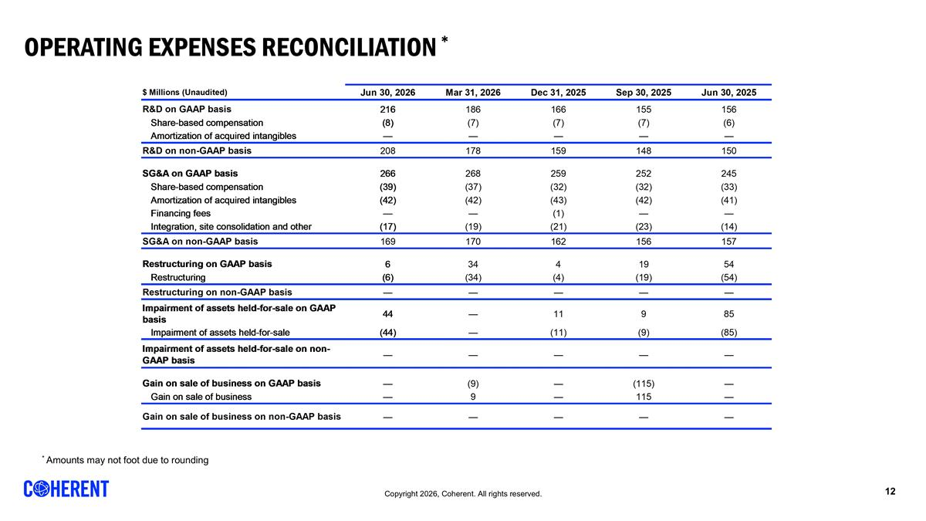
Operating ExpenseS Reconciliation * * Amounts may not foot due to rounding REVENUE BY SEGMENT [Data used for bar graph] $ Millions 45,838 45,930 46,022 46,112 46,203 Datacenter and Communications 1,018 1,090 1,208 1,362 1,615 0.79 0.70857315964859136 Industrial 511 491 478 444 431 0.21 Total 1,529 1,581 1,686 1,806 2,046 1 REVENUE BY MARKET [Data used for bar graph] $ Millions 45,838 45,930 46,022 46,112 46,203 Datacenter and Communications 1,018 1,090 1,208 1,362 1,615 0.79 Industrial 511 491 478 444 431 0.21 Total 1,529 1,581 1,686 1,806 2,046 1 REVENUE BY REGION [Data used for bar graph] $ Millions 45,382 45,473 45,565 45,657 45,747 North America 688 756 807 860 944 0.63 0.1 0.37 Europe 182 182 169 167 173 0.12 0.04 -0.05 Japan & Korea 155 167 165 187 177 0.12 -0.05 0.14000000000000001 China 154 173 170 184 161 0.11 rounded to foot -0.13 0.05 Other 30 36 37 37 43 0.03 0.16 0.43 Total 1,209 1,314 1,348 1,435 1,498 1 0.04 0.24 GROSS MARGIN RECONCILIATION $ Millions (Unaudited) 46,203 46,112 46,022 45,930 45,838 Gross margin on GAAP basis 787 680 623 579 546 Share-based compensation 7 6 6 6 6 Amortization of acquired intangibles 28 28 28 28 31 Fair value adjustment on acquired inventory 0 0 Start-up costs 0 0 Integration, site consolidation and other 0 0 0 0 0 Gross margin on non-GAAP basis 823 714 657 613 582 OPERATING EXPENSES RECONCILIATION $ Millions (Unaudited) 46,203 46,112 46,022 45,930 45,838 R&D on GAAP basis 216 186 166 155 156 Share-based compensation -8 -7 -7 -7 -6 Amortization of acquired intangibles 0 0 0 0 0 Start-up costs 0 0 Integration, site consolidation and other R&D on non-GAAP basis 208 178 159 148 150 SG&A on GAAP basis 266 268 259 252 245 Share-based compensation -39 -37 -32 -32 -33 Amortization of acquired intangibles -42 -42 -43 -42 -41 Financing fees 0 0 -1 0 0 Integration, site consolidation and other -17 -19 -21 -23 -14 SG&A on non-GAAP basis 169 170 162 156 157 Restructuring on GAAP basis 6 34 4 19 54 Restructuring -6 -34 -4 -19 -54 Restructuring on non-GAAP basis 0 0 0 0 0 Impairment of assets held-for-sale on GAAP basis 44 0 11 9 85 Impairment of assets held-for-sale -44 0 -11 -9 -85 Impairment of assets held-for-sale on non-GAAP basis 0 0 0 0 0 Gain on sale of business on GAAP basis 0 -9 0 -,115 0 Gain on sale of business 0 9 0 115 0 Gain on sale of business on non-GAAP basis 0 0 0 0 0 INCOME FROM OPERATIONS RECONCILIATION $ Millions (Unaudited) 46,203 46,112 46,022 45,930 45,838 Op. income on GAAP basis 254 201 184 259 6 Share-based compensation 54 51 45 45 44 Fair value adjustment on acquired inventory 0 0 0 0 0 Amortization of acquired intangibles 70 71 71 70 72 Restructuring charges 6 34 4 19 54 Financing fees 0 0 1 0 0 Impairment of assets held-for-sale 44 0 11 9 85 Gain on sale of business 0 -9 0 -,115 0 Integration, site consolidation and other 18 19 21 22 14 Op. income on non-GAAP basis 446 366 336 309 275 Non-GAAP Op. Margin Percentage 0.218 0.20300000000000001 0.19899999999999998 0.19500000000000001 0.18 NET EARNINGS RECONCILIATION $ Millions (Unaudited) 46,203 46,112 46,022 45,930 45,838 Net earnings (loss) attributable to Coherent Corp. on GAAP basis 241 191 147 226 -96 Share-based compensation 54 51 45 45 44 Amortization of acquired intangibles 70 71 71 70 72 Fair value adjustment on acquired inventory 0 0 Start-up costs 0 0 Foreign currency exch. (gains) losses -4 1 -2 -1 37 Restructuring charges 6 34 4 19 54 Impairment of assets held-for-sale 44 0 11 9 85 Gain on sale of business 0 -9 0 -,115 0 Integration, site consolidation and other 18 19 21 22 14 Gain on sale of investment -38 -14 -15 -7 0 Financing fees 0 0 1 12 0 Non-controlling interest impact of non-GAAP items 0 -6 0 0 0 Tax impact of non-GAAP measures -39 -61 -33 -60 -18 Net earnings attributable to Coherent Corp. on non-GAAP basis 351 276 248 221 192 GROSS MARGIN AND EARNINGS PER COMMON SHARE $ Millions (Unaudited) 46,203 46,112 46,022 45,930 45,838 Gross margin on GAAP basis 787 680 623 579 546 Share-based compensation 7 6 6 6 6 Amortization of acquired intangibles 28 28 28 28 31 Integration, site consolidation and other 0 0 0 0 0 Gross margin on non-GAAP basis 823 714 657 613 582 $ for EPS, $ Millions for shares (Unaudited) 46,203 46,112 46,022 45,930 45,838 Common shares, GAAP 195.7 190.2 167.5 156.19999999999999 155.5 Effect of dilutive securities: Common stock equivalents 6.6 6.1 5.5 4.5999999999999996 0 Series B Redeemable Preferred Stock 0 0 19.8 29.9 0 Diluted weighted average common shares, GAAP 202.2 196.4 192.8 190.7 155.5 Common shares, Non-GAAP 195.7 190.2 167.5 156.19999999999999 155.5 Effect of dilutive securities: Common stock equivalents 6.6 6.1 5.5 4.5999999999999996 3.7 Series B Redeemable Preferred Stock 0 0 19.8 29.9 0 Diluted weighted average common shares, Non-GAAP 202.2 196.4 192.8 190.7 159.19999999999999 Net earnings (loss) attributable to Coherent Corp., GAAP Basic Earnings (Loss) Per Share 1.23 1.01 0.87 1.24 -0.83 Diluted Earnings (Loss) Per Share 1.19 0.97 0.76 1.19 -0.83 Net earnings attributable to Coherent Corp., non-GAAP Basic Earnings Per Share 1.79 1.45 1.47 1.2 1.02 Diluted Earnings Per Share 1.74 1.41 1.29 1.1599999999999999 1 NET EARNINGS, GAAP, AND ADJUSTED EBITDA RECONCILIATION $ Millions (Unaudited) 46,203 46,112 46,022 45,930 45,838 Net earnings (loss) on GAAP basis 236 182 144 225 -98 Income taxes (benefit) 42 3 24 -8 35 Depreciation and amortization 141 133 126 122 135 Interest expense 41 45 46 59 55 Interest income -19 -11 -10 -10 -11 EBITDA 441 351 330 389 116 EBITDA margin 0.21600000000000003 0.19399999999999998 0.19600000000000001 0.24600000000000002 7.5999999999999998 Prelim. fair value adj. on acquired inv. 0 0 Share-based compensation 45 51 45 45 44 Foreign currency exch. (gains) losses -2 1 -2 -1 37 Start-up costs 0 0 Restructuring charges 6 34 4 19 54 Impairment of assets held-for-sale 44 0 11 9 85 Gain on sale of business 0 -9 0 -,115 0 Financing fees -38 -14 -14 6 0 Integration, site consolidation and other 18 19 21 22 14 Adjusted EBITDA 521 433 395 347 350 Less: adjusted EBITDA attributable to noncontrolling interests 3 3 1 0 1 Adjusted EBITDA attributable to Coherent Corp. 524 436 396 373 351 Adjusted EBITDA margin attributable to Coherent Corp. 0.25600000000000001 0.24100000000000002 0.23500000000000001 0.23600000000000002 0.22899999999999998 NET EARNINGS RECONCILIATION, GAAP to non-GAAP $ Millions (Unaudited) 46,203 Net earnings attributable to Coherent Corp. on GAAP basis 241 Share-based compensation 54 Amortization of acquired intangibles 70 Foreign currency exch. (gains) losses -4 Restructuring charges 6 Impairment of assets held-for-sale 44 Gain on sale of business 0 Integration, site consolidation and other 18 Gain on sale of investment -38 Financing fees 0 Non-controlling interest impact of non-GAAP items 0 Tax impact of non-GAAP measures -39 Net earnings attributable to Coherent Corp. on non-GAAP basis 351 Basic weighted average shares, GAAP 195.7 Diluted weighted average shares, GAAP 202.2 Diluted weighted average shares, non-GAAP 202.2 Net diluted earnings per share attributable to Coherent Corp., GAAP $1.19 Net earnings per share attributable to Coherent Corp., non-GAAP $1.74 REVENUE BY SEGMENT [Data used for bar graph] $ Millions 45,838 45,930 46,022 46,112 46,203 Datacenter and Communications 1,018 1,090 1,208 1,362 1,615 0.79 0.70857315964859136 Industrial 511 491 478 444 431 0.21 Total 1,529 1,581 1,686 1,806 2,046 1 REVENUE BY MARKET [Data used for bar graph] $ Millions 45,838 45,930 46,022 46,112 46,203 Datacenter and Communications 1,018 1,090 1,208 1,362 1,615 0.79 Industrial 511 491 478 444 431 0.21 Total 1,529 1,581 1,686 1,806 2,046 1 REVENUE BY REGION [Data used for bar graph] $ Millions 45,382 45,473 45,565 45,657 45,747 North America 688 756 807 860 944 0.63 0.1 0.37 Europe 182 182 169 167 173 0.12 0.04 -0.05 Japan & Korea 155 167 165 187 177 0.12 -0.05 0.14000000000000001 China 154 173 170 184 161 0.11 rounded to foot -0.13 0.05 Other 30 36 37 37 43 0.03 0.16 0.43 Total 1,209 1,314 1,348 1,435 1,498 1 0.04 0.24 GROSS MARGIN RECONCILIATION $ Millions (Unaudited) 46,203 46,112 46,022 45,930 45,838 Gross margin on GAAP basis 787 680 623 579 546 Share-based compensation 7 6 6 6 6 Amortization of acquired intangibles 28 28 28 28 31 Fair value adjustment on acquired inventory 0 0 Start-up costs 0 0 Integration, site consolidation and other 0 0 0 0 0 Gross margin on non-GAAP basis 823 714 657 613 582 OPERATING EXPENSES RECONCILIATION $ Millions (Unaudited) 46,203 46,112 46,022 45,930 45,838 R&D on GAAP basis 216 186 166 155 156 Share-based compensation -8 -7 -7 -7 -6 Amortization of acquired intangibles 0 0 0 0 0 Start-up costs 0 0 Integration, site consolidation and other R&D on non-GAAP basis 208 178 159 148 150 SG&A on GAAP basis 266 268 259 252 245 Share-based compensation -39 -37 -32 -32 -33 Amortization of acquired intangibles -42 -42 -43 -42 -41 Financing fees 0 0 -1 0 0 Integration, site consolidation and other -17 -19 -21 -23 -14 SG&A on non-GAAP basis 169 170 162 156 157 Restructuring on GAAP basis 6 34 4 19 54 Restructuring -6 -34 -4 -19 -54 Restructuring on non-GAAP basis 0 0 0 0 0 Impairment of assets held-for-sale on GAAP basis 44 0 11 9 85 Impairment of assets held-for-sale -44 0 -11 -9 -85 Impairment of assets held-for-sale on non-GAAP basis 0 0 0 0 0 Gain on sale of business on GAAP basis 0 -9 0 -,115 0 Gain on sale of business 0 9 0 115 0 Gain on sale of business on non-GAAP basis 0 0 0 0 0 INCOME FROM OPERATIONS RECONCILIATION $ Millions (Unaudited) 46,203 46,112 46,022 45,930 45,838 Op. income on GAAP basis 254 201 184 259 6 Share-based compensation 54 51 45 45 44 Fair value adjustment on acquired inventory 0 0 0 0 0 Amortization of acquired intangibles 70 71 71 70 72 Restructuring charges 6 34 4 19 54 Financing fees 0 0 1 0 0 Impairment of assets held-for-sale 44 0 11 9 85 Gain on sale of business 0 -9 0 -,115 0 Integration, site consolidation and other 18 19 21 22 14 Op. income on non-GAAP basis 446 366 336 309 275 Non-GAAP Op. Margin Percentage 0.218 0.20300000000000001 0.19899999999999998 0.19500000000000001 0.18 NET EARNINGS RECONCILIATION $ Millions (Unaudited) 46,203 46,112 46,022 45,930 45,838 Net earnings (loss) attributable to Coherent Corp. on GAAP basis 241 191 147 226 -96 Share-based compensation 54 51 45 45 44 Amortization of acquired intangibles 70 71 71 70 72 Fair value adjustment on acquired inventory 0 0 Start-up costs 0 0 Foreign currency exch. (gains) losses -4 1 -2 -1 37 Restructuring charges 6 34 4 19 54 Impairment of assets held-for-sale 44 0 11 9 85 Gain on sale of business 0 -9 0 -,115 0 Integration, site consolidation and other 18 19 21 22 14 Gain on sale of investment -38 -14 -15 -7 0 Financing fees 0 0 1 12 0 Non-controlling interest impact of non-GAAP items 0 -6 0 0 0 Tax impact of non-GAAP measures -39 -61 -33 -60 -18 Net earnings attributable to Coherent Corp. on non-GAAP basis 351 276 248 221 192 GROSS MARGIN AND EARNINGS PER COMMON SHARE $ Millions (Unaudited) 46,203 46,112 46,022 45,930 45,838 Gross margin on GAAP basis 787 680 623 579 546 Share-based compensation 7 6 6 6 6 Amortization of acquired intangibles 28 28 28 28 31 Integration, site consolidation and other 0 0 0 0 0 Gross margin on non-GAAP basis 823 714 657 613 582 $ for EPS, $ Millions for shares (Unaudited) 46,203 46,112 46,022 45,930 45,838 Common shares, GAAP 195.7 190.2 167.5 156.19999999999999 155.5 Effect of dilutive securities: Common stock equivalents 6.6 6.1 5.5 4.5999999999999996 0 Series B Redeemable Preferred Stock 0 0 19.8 29.9 0 Diluted weighted average common shares, GAAP 202.2 196.4 192.8 190.7 155.5 Common shares, Non-GAAP 195.7 190.2 167.5 156.19999999999999 155.5 Effect of dilutive securities: Common stock equivalents 6.6 6.1 5.5 4.5999999999999996 3.7 Series B Redeemable Preferred Stock 0 0 19.8 29.9 0 Diluted weighted average common shares, Non-GAAP 202.2 196.4 192.8 190.7 159.19999999999999 Net earnings (loss) attributable to Coherent Corp., GAAP Basic Earnings (Loss) Per Share 1.23 1.01 0.87 1.24 -0.83 Diluted Earnings (Loss) Per Share 1.19 0.97 0.76 1.19 -0.83 Net earnings attributable to Coherent Corp., non-GAAP Basic Earnings Per Share 1.79 1.45 1.47 1.2 1.02 Diluted Earnings Per Share 1.74 1.41 1.29 1.1599999999999999 1 NET EARNINGS, GAAP, AND ADJUSTED EBITDA RECONCILIATION $ Millions (Unaudited) 46,203 46,112 46,022 45,930 45,838 Net earnings (loss) on GAAP basis 236 182 144 225 -98 Income taxes (benefit) 42 3 24 -8 35 Depreciation and amortization 141 133 126 122 135 Interest expense 41 45 46 59 55 Interest income -19 -11 -10 -10 -11 EBITDA 441 351 330 389 116 EBITDA margin 0.21600000000000003 0.19399999999999998 0.19600000000000001 0.24600000000000002 7.5999999999999998 Prelim. fair value adj. on acquired inv. 0 0 Share-based compensation 45 51 45 45 44 Foreign currency exch. (gains) losses -2 1 -2 -1 37 Start-up costs 0 0 Restructuring charges 6 34 4 19 54 Impairment of assets held-for-sale 44 0 11 9 85 Gain on sale of business 0 -9 0 -,115 0 Financing fees -38 -14 -14 6 0 Integration, site consolidation and other 18 19 21 22 14 Adjusted EBITDA 521 433 395 347 350 Less: adjusted EBITDA attributable to noncontrolling interests 3 3 1 0 1 Adjusted EBITDA attributable to Coherent Corp. 524 436 396 373 351 Adjusted EBITDA margin attributable to Coherent Corp. 0.25600000000000001 0.24100000000000002 0.23500000000000001 0.23600000000000002 0.22899999999999998 NET EARNINGS RECONCILIATION, GAAP to non-GAAP $ Millions (Unaudited) 46,203 Net earnings attributable to Coherent Corp. on GAAP basis 241 Share-based compensation 54 Amortization of acquired intangibles 70 Foreign currency exch. (gains) losses -4 Restructuring charges 6 Impairment of assets held-for-sale 44 Gain on sale of business 0 Integration, site consolidation and other 18 Gain on sale of investment -38 Financing fees 0 Non-controlling interest impact of non-GAAP items 0 Tax impact of non-GAAP measures -39 Net earnings attributable to Coherent Corp. on non-GAAP basis 351 Basic weighted average shares, GAAP 195.7 Diluted weighted average shares, GAAP 202.2 Diluted weighted average shares, non-GAAP 202.2 Net diluted earnings per share attributable to Coherent Corp., GAAP $1.19 Net earnings per share attributable to Coherent Corp., non-GAAP $1.74

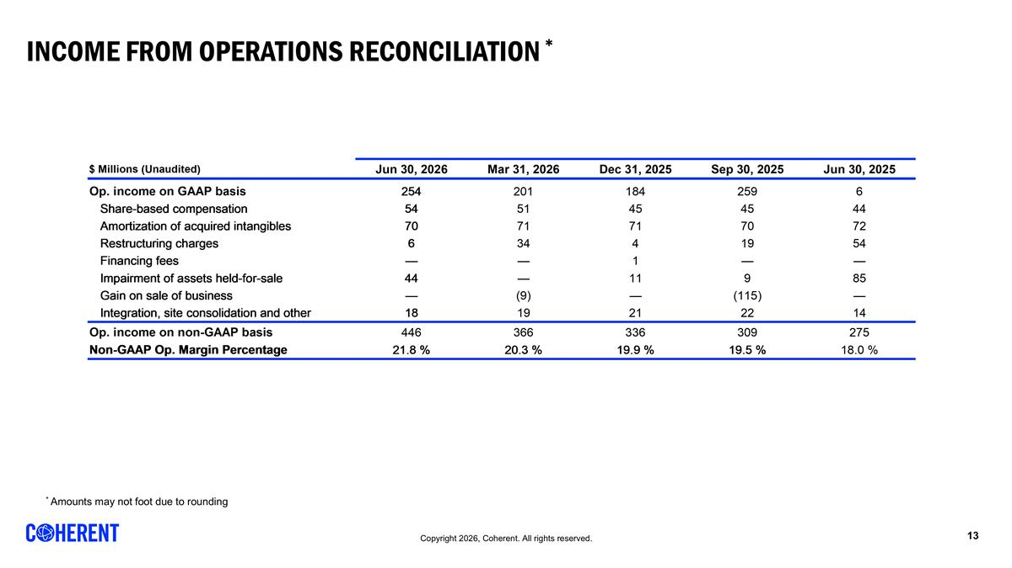
Income from Operations Reconciliation * * Amounts may not foot due to rounding REVENUE BY SEGMENT [Data used for bar graph] $ Millions 45,838 45,930 46,022 46,112 46,203 Datacenter and Communications 1,018 1,090 1,208 1,362 1,615 0.79 0.70857315964859136 Industrial 511 491 478 444 431 0.21 Total 1,529 1,581 1,686 1,806 2,046 1 REVENUE BY MARKET [Data used for bar graph] $ Millions 45,838 45,930 46,022 46,112 46,203 Datacenter and Communications 1,018 1,090 1,208 1,362 1,615 0.79 Industrial 511 491 478 444 431 0.21 Total 1,529 1,581 1,686 1,806 2,046 1 REVENUE BY REGION [Data used for bar graph] $ Millions 45,382 45,473 45,565 45,657 45,747 North America 688 756 807 860 944 0.63 0.1 0.37 Europe 182 182 169 167 173 0.12 0.04 -0.05 Japan & Korea 155 167 165 187 177 0.12 -0.05 0.14000000000000001 China 154 173 170 184 161 0.11 rounded to foot -0.13 0.05 Other 30 36 37 37 43 0.03 0.16 0.43 Total 1,209 1,314 1,348 1,435 1,498 1 0.04 0.24 GROSS MARGIN RECONCILIATION $ Millions (Unaudited) 46,203 46,112 46,022 45,930 45,838 Gross margin on GAAP basis 787 680 623 579 546 Share-based compensation 7 6 6 6 6 Amortization of acquired intangibles 28 28 28 28 31 Fair value adjustment on acquired inventory 0 0 Start-up costs 0 0 Integration, site consolidation and other 0 0 0 0 0 Gross margin on non-GAAP basis 823 714 657 613 582 OPERATING EXPENSES RECONCILIATION $ Millions (Unaudited) 46,203 46,112 46,022 45,930 45,838 R&D on GAAP basis 216 186 166 155 156 Share-based compensation -8 -7 -7 -7 -6 Amortization of acquired intangibles 0 0 0 0 0 Start-up costs 0 0 Integration, site consolidation and other R&D on non-GAAP basis 208 178 159 148 150 SG&A on GAAP basis 266 268 259 252 245 Share-based compensation -39 -37 -32 -32 -33 Amortization of acquired intangibles -42 -42 -43 -42 -41 Financing fees 0 0 -1 0 0 Integration, site consolidation and other -17 -19 -21 -23 -14 SG&A on non-GAAP basis 169 170 162 156 157 Restructuring on GAAP basis 6 34 4 19 54 Restructuring -6 -34 -4 -19 -54 Restructuring on non-GAAP basis 0 0 0 0 0 Impairment of assets held-for-sale on GAAP basis 44 0 11 9 85 Impairment of assets held-for-sale -44 0 -11 -9 -85 Impairment of assets held-for-sale on non-GAAP basis 0 0 0 0 0 Gain on sale of business on GAAP basis 0 -9 0 -,115 0 Gain on sale of business 0 9 0 115 0 Gain on sale of business on non-GAAP basis 0 0 0 0 0 INCOME FROM OPERATIONS RECONCILIATION $ Millions (Unaudited) 46,203 46,112 46,022 45,930 45,838 Op. income on GAAP basis 254 201 184 259 6 Share-based compensation 54 51 45 45 44 Fair value adjustment on acquired inventory 0 0 0 0 0 Amortization of acquired intangibles 70 71 71 70 72 Restructuring charges 6 34 4 19 54 Financing fees 0 0 1 0 0 Impairment of assets held-for-sale 44 0 11 9 85 Gain on sale of business 0 -9 0 -,115 0 Integration, site consolidation and other 18 19 21 22 14 Op. income on non-GAAP basis 446 366 336 309 275 Non-GAAP Op. Margin Percentage 0.218 0.20300000000000001 0.19899999999999998 0.19500000000000001 0.18 NET EARNINGS RECONCILIATION $ Millions (Unaudited) 46,203 46,112 46,022 45,930 45,838 Net earnings (loss) attributable to Coherent Corp. on GAAP basis 241 191 147 226 -96 Share-based compensation 54 51 45 45 44 Amortization of acquired intangibles 70 71 71 70 72 Fair value adjustment on acquired inventory 0 0 Start-up costs 0 0 Foreign currency exch. (gains) losses -4 1 -2 -1 37 Restructuring charges 6 34 4 19 54 Impairment of assets held-for-sale 44 0 11 9 85 Gain on sale of business 0 -9 0 -,115 0 Integration, site consolidation and other 18 19 21 22 14 Gain on sale of investment -38 -14 -15 -7 0 Financing fees 0 0 1 12 0 Non-controlling interest impact of non-GAAP items 0 -6 0 0 0 Tax impact of non-GAAP measures -39 -61 -33 -60 -18 Net earnings attributable to Coherent Corp. on non-GAAP basis 351 276 248 221 192 GROSS MARGIN AND EARNINGS PER COMMON SHARE $ Millions (Unaudited) 46,203 46,112 46,022 45,930 45,838 Gross margin on GAAP basis 787 680 623 579 546 Share-based compensation 7 6 6 6 6 Amortization of acquired intangibles 28 28 28 28 31 Integration, site consolidation and other 0 0 0 0 0 Gross margin on non-GAAP basis 823 714 657 613 582 $ for EPS, $ Millions for shares (Unaudited) 46,203 46,112 46,022 45,930 45,838 Common shares, GAAP 195.7 190.2 167.5 156.19999999999999 155.5 Effect of dilutive securities: Common stock equivalents 6.6 6.1 5.5 4.5999999999999996 0 Series B Redeemable Preferred Stock 0 0 19.8 29.9 0 Diluted weighted average common shares, GAAP 202.2 196.4 192.8 190.7 155.5 Common shares, Non-GAAP 195.7 190.2 167.5 156.19999999999999 155.5 Effect of dilutive securities: Common stock equivalents 6.6 6.1 5.5 4.5999999999999996 3.7 Series B Redeemable Preferred Stock 0 0 19.8 29.9 0 Diluted weighted average common shares, Non-GAAP 202.2 196.4 192.8 190.7 159.19999999999999 Net earnings (loss) attributable to Coherent Corp., GAAP Basic Earnings (Loss) Per Share 1.23 1.01 0.87 1.24 -0.83 Diluted Earnings (Loss) Per Share 1.19 0.97 0.76 1.19 -0.83 Net earnings attributable to Coherent Corp., non-GAAP Basic Earnings Per Share 1.79 1.45 1.47 1.2 1.02 Diluted Earnings Per Share 1.74 1.41 1.29 1.1599999999999999 1 NET EARNINGS, GAAP, AND ADJUSTED EBITDA RECONCILIATION $ Millions (Unaudited) 46,203 46,112 46,022 45,930 45,838 Net earnings (loss) on GAAP basis 236 182 144 225 -98 Income taxes (benefit) 42 3 24 -8 35 Depreciation and amortization 141 133 126 122 135 Interest expense 41 45 46 59 55 Interest income -19 -11 -10 -10 -11 EBITDA 441 351 330 389 116 EBITDA margin 0.21600000000000003 0.19399999999999998 0.19600000000000001 0.24600000000000002 7.5999999999999998 Prelim. fair value adj. on acquired inv. 0 0 Share-based compensation 45 51 45 45 44 Foreign currency exch. (gains) losses -2 1 -2 -1 37 Start-up costs 0 0 Restructuring charges 6 34 4 19 54 Impairment of assets held-for-sale 44 0 11 9 85 Gain on sale of business 0 -9 0 -,115 0 Financing fees -38 -14 -14 6 0 Integration, site consolidation and other 18 19 21 22 14 Adjusted EBITDA 521 433 395 347 350 Less: adjusted EBITDA attributable to noncontrolling interests 3 3 1 0 1 Adjusted EBITDA attributable to Coherent Corp. 524 436 396 373 351 Adjusted EBITDA margin attributable to Coherent Corp. 0.25600000000000001 0.24100000000000002 0.23500000000000001 0.23600000000000002 0.22899999999999998 NET EARNINGS RECONCILIATION, GAAP to non-GAAP $ Millions (Unaudited) 46,203 Net earnings attributable to Coherent Corp. on GAAP basis 241 Share-based compensation 54 Amortization of acquired intangibles 70 Foreign currency exch. (gains) losses -4 Restructuring charges 6 Impairment of assets held-for-sale 44 Gain on sale of business 0 Integration, site consolidation and other 18 Gain on sale of investment -38 Financing fees 0 Non-controlling interest impact of non-GAAP items 0 Tax impact of non-GAAP measures -39 Net earnings attributable to Coherent Corp. on non-GAAP basis 351 Basic weighted average shares, GAAP 195.7 Diluted weighted average shares, GAAP 202.2 Diluted weighted average shares, non-GAAP 202.2 Net diluted earnings per share attributable to Coherent Corp., GAAP $1.19 Net earnings per share attributable to Coherent Corp., non-GAAP $1.74 REVENUE BY SEGMENT [Data used for bar graph] $ Millions 45,838 45,930 46,022 46,112 46,203 Datacenter and Communications 1,018 1,090 1,208 1,362 1,615 0.79 0.70857315964859136 Industrial 511 491 478 444 431 0.21 Total 1,529 1,581 1,686 1,806 2,046 1 REVENUE BY MARKET [Data used for bar graph] $ Millions 45,838 45,930 46,022 46,112 46,203 Datacenter and Communications 1,018 1,090 1,208 1,362 1,615 0.79 Industrial 511 491 478 444 431 0.21 Total 1,529 1,581 1,686 1,806 2,046 1 REVENUE BY REGION [Data used for bar graph] $ Millions 45,382 45,473 45,565 45,657 45,747 North America 688 756 807 860 944 0.63 0.1 0.37 Europe 182 182 169 167 173 0.12 0.04 -0.05 Japan & Korea 155 167 165 187 177 0.12 -0.05 0.14000000000000001 China 154 173 170 184 161 0.11 rounded to foot -0.13 0.05 Other 30 36 37 37 43 0.03 0.16 0.43 Total 1,209 1,314 1,348 1,435 1,498 1 0.04 0.24 GROSS MARGIN RECONCILIATION $ Millions (Unaudited) 46,203 46,112 46,022 45,930 45,838 Gross margin on GAAP basis 787 680 623 579 546 Share-based compensation 7 6 6 6 6 Amortization of acquired intangibles 28 28 28 28 31 Fair value adjustment on acquired inventory 0 0 Start-up costs 0 0 Integration, site consolidation and other 0 0 0 0 0 Gross margin on non-GAAP basis 823 714 657 613 582 OPERATING EXPENSES RECONCILIATION $ Millions (Unaudited) 46,203 46,112 46,022 45,930 45,838 R&D on GAAP basis 216 186 166 155 156 Share-based compensation -8 -7 -7 -7 -6 Amortization of acquired intangibles 0 0 0 0 0 Start-up costs 0 0 Integration, site consolidation and other R&D on non-GAAP basis 208 178 159 148 150 SG&A on GAAP basis 266 268 259 252 245 Share-based compensation -39 -37 -32 -32 -33 Amortization of acquired intangibles -42 -42 -43 -42 -41 Financing fees 0 0 -1 0 0 Integration, site consolidation and other -17 -19 -21 -23 -14 SG&A on non-GAAP basis 169 170 162 156 157 Restructuring on GAAP basis 6 34 4 19 54 Restructuring -6 -34 -4 -19 -54 Restructuring on non-GAAP basis 0 0 0 0 0 Impairment of assets held-for-sale on GAAP basis 44 0 11 9 85 Impairment of assets held-for-sale -44 0 -11 -9 -85 Impairment of assets held-for-sale on non-GAAP basis 0 0 0 0 0 Gain on sale of business on GAAP basis 0 -9 0 -,115 0 Gain on sale of business 0 9 0 115 0 Gain on sale of business on non-GAAP basis 0 0 0 0 0 INCOME FROM OPERATIONS RECONCILIATION $ Millions (Unaudited) 46,203 46,112 46,022 45,930 45,838 Op. income on GAAP basis 254 201 184 259 6 Share-based compensation 54 51 45 45 44 Fair value adjustment on acquired inventory 0 0 0 0 0 Amortization of acquired intangibles 70 71 71 70 72 Restructuring charges 6 34 4 19 54 Financing fees 0 0 1 0 0 Impairment of assets held-for-sale 44 0 11 9 85 Gain on sale of business 0 -9 0 -,115 0 Integration, site consolidation and other 18 19 21 22 14 Op. income on non-GAAP basis 446 366 336 309 275 Non-GAAP Op. Margin Percentage 0.218 0.20300000000000001 0.19899999999999998 0.19500000000000001 0.18 NET EARNINGS RECONCILIATION $ Millions (Unaudited) 46,203 46,112 46,022 45,930 45,838 Net earnings (loss) attributable to Coherent Corp. on GAAP basis 241 191 147 226 -96 Share-based compensation 54 51 45 45 44 Amortization of acquired intangibles 70 71 71 70 72 Fair value adjustment on acquired inventory 0 0 Start-up costs 0 0 Foreign currency exch. (gains) losses -4 1 -2 -1 37 Restructuring charges 6 34 4 19 54 Impairment of assets held-for-sale 44 0 11 9 85 Gain on sale of business 0 -9 0 -,115 0 Integration, site consolidation and other 18 19 21 22 14 Gain on sale of investment -38 -14 -15 -7 0 Financing fees 0 0 1 12 0 Non-controlling interest impact of non-GAAP items 0 -6 0 0 0 Tax impact of non-GAAP measures -39 -61 -33 -60 -18 Net earnings attributable to Coherent Corp. on non-GAAP basis 351 276 248 221 192 GROSS MARGIN AND EARNINGS PER COMMON SHARE $ Millions (Unaudited) 46,203 46,112 46,022 45,930 45,838 Gross margin on GAAP basis 787 680 623 579 546 Share-based compensation 7 6 6 6 6 Amortization of acquired intangibles 28 28 28 28 31 Integration, site consolidation and other 0 0 0 0 0 Gross margin on non-GAAP basis 823 714 657 613 582 $ for EPS, $ Millions for shares (Unaudited) 46,203 46,112 46,022 45,930 45,838 Common shares, GAAP 195.7 190.2 167.5 156.19999999999999 155.5 Effect of dilutive securities: Common stock equivalents 6.6 6.1 5.5 4.5999999999999996 0 Series B Redeemable Preferred Stock 0 0 19.8 29.9 0 Diluted weighted average common shares, GAAP 202.2 196.4 192.8 190.7 155.5 Common shares, Non-GAAP 195.7 190.2 167.5 156.19999999999999 155.5 Effect of dilutive securities: Common stock equivalents 6.6 6.1 5.5 4.5999999999999996 3.7 Series B Redeemable Preferred Stock 0 0 19.8 29.9 0 Diluted weighted average common shares, Non-GAAP 202.2 196.4 192.8 190.7 159.19999999999999 Net earnings (loss) attributable to Coherent Corp., GAAP Basic Earnings (Loss) Per Share 1.23 1.01 0.87 1.24 -0.83 Diluted Earnings (Loss) Per Share 1.19 0.97 0.76 1.19 -0.83 Net earnings attributable to Coherent Corp., non-GAAP Basic Earnings Per Share 1.79 1.45 1.47 1.2 1.02 Diluted Earnings Per Share 1.74 1.41 1.29 1.1599999999999999 1 NET EARNINGS, GAAP, AND ADJUSTED EBITDA RECONCILIATION $ Millions (Unaudited) 46,203 46,112 46,022 45,930 45,838 Net earnings (loss) on GAAP basis 236 182 144 225 -98 Income taxes (benefit) 42 3 24 -8 35 Depreciation and amortization 141 133 126 122 135 Interest expense 41 45 46 59 55 Interest income -19 -11 -10 -10 -11 EBITDA 441 351 330 389 116 EBITDA margin 0.21600000000000003 0.19399999999999998 0.19600000000000001 0.24600000000000002 7.5999999999999998 Prelim. fair value adj. on acquired inv. 0 0 Share-based compensation 45 51 45 45 44 Foreign currency exch. (gains) losses -2 1 -2 -1 37 Start-up costs 0 0 Restructuring charges 6 34 4 19 54 Impairment of assets held-for-sale 44 0 11 9 85 Gain on sale of business 0 -9 0 -,115 0 Financing fees -38 -14 -14 6 0 Integration, site consolidation and other 18 19 21 22 14 Adjusted EBITDA 521 433 395 347 350 Less: adjusted EBITDA attributable to noncontrolling interests 3 3 1 0 1 Adjusted EBITDA attributable to Coherent Corp. 524 436 396 373 351 Adjusted EBITDA margin attributable to Coherent Corp. 0.25600000000000001 0.24100000000000002 0.23500000000000001 0.23600000000000002 0.22899999999999998 NET EARNINGS RECONCILIATION, GAAP to non-GAAP $ Millions (Unaudited) 46,203 Net earnings attributable to Coherent Corp. on GAAP basis 241 Share-based compensation 54 Amortization of acquired intangibles 70 Foreign currency exch. (gains) losses -4 Restructuring charges 6 Impairment of assets held-for-sale 44 Gain on sale of business 0 Integration, site consolidation and other 18 Gain on sale of investment -38 Financing fees 0 Non-controlling interest impact of non-GAAP items 0 Tax impact of non-GAAP measures -39 Net earnings attributable to Coherent Corp. on non-GAAP basis 351 Basic weighted average shares, GAAP 195.7 Diluted weighted average shares, GAAP 202.2 Diluted weighted average shares, non-GAAP 202.2 Net diluted earnings per share attributable to Coherent Corp., GAAP $1.19 Net earnings per share attributable to Coherent Corp., non-GAAP $1.74

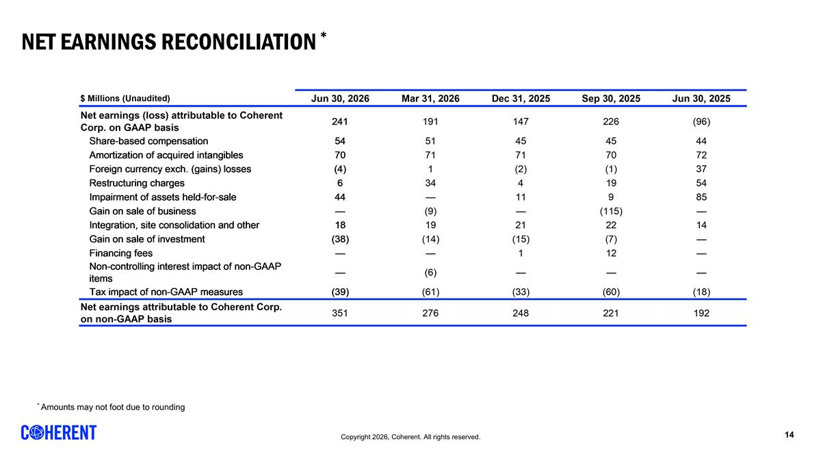
Net Earnings Reconciliation * * Amounts may not foot due to rounding REVENUE BY SEGMENT [Data used for bar graph] $ Millions 45,838 45,930 46,022 46,112 46,203 Datacenter and Communications 1,018 1,090 1,208 1,362 1,615 0.79 0.70857315964859136 Industrial 511 491 478 444 431 0.21 Total 1,529 1,581 1,686 1,806 2,046 1 REVENUE BY MARKET [Data used for bar graph] $ Millions 45,838 45,930 46,022 46,112 46,203 Datacenter and Communications 1,018 1,090 1,208 1,362 1,615 0.79 Industrial 511 491 478 444 431 0.21 Total 1,529 1,581 1,686 1,806 2,046 1 REVENUE BY REGION [Data used for bar graph] $ Millions 45,382 45,473 45,565 45,657 45,747 North America 688 756 807 860 944 0.63 0.1 0.37 Europe 182 182 169 167 173 0.12 0.04 -0.05 Japan & Korea 155 167 165 187 177 0.12 -0.05 0.14000000000000001 China 154 173 170 184 161 0.11 rounded to foot -0.13 0.05 Other 30 36 37 37 43 0.03 0.16 0.43 Total 1,209 1,314 1,348 1,435 1,498 1 0.04 0.24 GROSS MARGIN RECONCILIATION $ Millions (Unaudited) 46,203 46,112 46,022 45,930 45,838 Gross margin on GAAP basis 787 680 623 579 546 Share-based compensation 7 6 6 6 6 Amortization of acquired intangibles 28 28 28 28 31 Fair value adjustment on acquired inventory 0 0 Start-up costs 0 0 Integration, site consolidation and other 0 0 0 0 0 Gross margin on non-GAAP basis 823 714 657 613 582 OPERATING EXPENSES RECONCILIATION $ Millions (Unaudited) 46,203 46,112 46,022 45,930 45,838 R&D on GAAP basis 216 186 166 155 156 Share-based compensation -8 -7 -7 -7 -6 Amortization of acquired intangibles 0 0 0 0 0 Start-up costs 0 0 Integration, site consolidation and other R&D on non-GAAP basis 208 178 159 148 150 SG&A on GAAP basis 266 268 259 252 245 Share-based compensation -39 -37 -32 -32 -33 Amortization of acquired intangibles -42 -42 -43 -42 -41 Financing fees 0 0 -1 0 0 Integration, site consolidation and other -17 -19 -21 -23 -14 SG&A on non-GAAP basis 169 170 162 156 157 Restructuring on GAAP basis 6 34 4 19 54 Restructuring -6 -34 -4 -19 -54 Restructuring on non-GAAP basis 0 0 0 0 0 Impairment of assets held-for-sale on GAAP basis 44 0 11 9 85 Impairment of assets held-for-sale -44 0 -11 -9 -85 Impairment of assets held-for-sale on non-GAAP basis 0 0 0 0 0 Gain on sale of business on GAAP basis 0 -9 0 -,115 0 Gain on sale of business 0 9 0 115 0 Gain on sale of business on non-GAAP basis 0 0 0 0 0 INCOME FROM OPERATIONS RECONCILIATION $ Millions (Unaudited) 46,203 46,112 46,022 45,930 45,838 Op. income on GAAP basis 254 201 184 259 6 Share-based compensation 54 51 45 45 44 Fair value adjustment on acquired inventory 0 0 0 0 0 Amortization of acquired intangibles 70 71 71 70 72 Restructuring charges 6 34 4 19 54 Financing fees 0 0 1 0 0 Impairment of assets held-for-sale 44 0 11 9 85 Gain on sale of business 0 -9 0 -,115 0 Integration, site consolidation and other 18 19 21 22 14 Op. income on non-GAAP basis 446 366 336 309 275 Non-GAAP Op. Margin Percentage 0.218 0.20300000000000001 0.19899999999999998 0.19500000000000001 0.18 NET EARNINGS RECONCILIATION $ Millions (Unaudited) 46,203 46,112 46,022 45,930 45,838 Net earnings (loss) attributable to Coherent Corp. on GAAP basis 241 191 147 226 -96 Share-based compensation 54 51 45 45 44 Amortization of acquired intangibles 70 71 71 70 72 Fair value adjustment on acquired inventory 0 0 Start-up costs 0 0 Foreign currency exch. (gains) losses -4 1 -2 -1 37 Restructuring charges 6 34 4 19 54 Impairment of assets held-for-sale 44 0 11 9 85 Gain on sale of business 0 -9 0 -,115 0 Integration, site consolidation and other 18 19 21 22 14 Gain on sale of investment -38 -14 -15 -7 0 Financing fees 0 0 1 12 0 Non-controlling interest impact of non-GAAP items 0 -6 0 0 0 Tax impact of non-GAAP measures -39 -61 -33 -60 -18 Net earnings attributable to Coherent Corp. on non-GAAP basis 351 276 248 221 192 GROSS MARGIN AND EARNINGS PER COMMON SHARE $ Millions (Unaudited) 46,203 46,112 46,022 45,930 45,838 Gross margin on GAAP basis 787 680 623 579 546 Share-based compensation 7 6 6 6 6 Amortization of acquired intangibles 28 28 28 28 31 Integration, site consolidation and other 0 0 0 0 0 Gross margin on non-GAAP basis 823 714 657 613 582 $ for EPS, $ Millions for shares (Unaudited) 46,203 46,112 46,022 45,930 45,838 Common shares, GAAP 195.7 190.2 167.5 156.19999999999999 155.5 Effect of dilutive securities: Common stock equivalents 6.6 6.1 5.5 4.5999999999999996 0 Series B Redeemable Preferred Stock 0 0 19.8 29.9 0 Diluted weighted average common shares, GAAP 202.2 196.4 192.8 190.7 155.5 Common shares, Non-GAAP 195.7 190.2 167.5 156.19999999999999 155.5 Effect of dilutive securities: Common stock equivalents 6.6 6.1 5.5 4.5999999999999996 3.7 Series B Redeemable Preferred Stock 0 0 19.8 29.9 0 Diluted weighted average common shares, Non-GAAP 202.2 196.4 192.8 190.7 159.19999999999999 Net earnings (loss) attributable to Coherent Corp., GAAP Basic Earnings (Loss) Per Share 1.23 1.01 0.87 1.24 -0.83 Diluted Earnings (Loss) Per Share 1.19 0.97 0.76 1.19 -0.83 Net earnings attributable to Coherent Corp., non-GAAP Basic Earnings Per Share 1.79 1.45 1.47 1.2 1.02 Diluted Earnings Per Share 1.74 1.41 1.29 1.1599999999999999 1 NET EARNINGS, GAAP, AND ADJUSTED EBITDA RECONCILIATION $ Millions (Unaudited) 46,203 46,112 46,022 45,930 45,838 Net earnings (loss) on GAAP basis 236 182 144 225 -98 Income taxes (benefit) 42 3 24 -8 35 Depreciation and amortization 141 133 126 122 135 Interest expense 41 45 46 59 55 Interest income -19 -11 -10 -10 -11 EBITDA 441 351 330 389 116 EBITDA margin 0.21600000000000003 0.19399999999999998 0.19600000000000001 0.24600000000000002 7.5999999999999998 Prelim. fair value adj. on acquired inv. 0 0 Share-based compensation 45 51 45 45 44 Foreign currency exch. (gains) losses -2 1 -2 -1 37 Start-up costs 0 0 Restructuring charges 6 34 4 19 54 Impairment of assets held-for-sale 44 0 11 9 85 Gain on sale of business 0 -9 0 -,115 0 Financing fees -38 -14 -14 6 0 Integration, site consolidation and other 18 19 21 22 14 Adjusted EBITDA 521 433 395 347 350 Less: adjusted EBITDA attributable to noncontrolling interests 3 3 1 0 1 Adjusted EBITDA attributable to Coherent Corp. 524 436 396 373 351 Adjusted EBITDA margin attributable to Coherent Corp. 0.25600000000000001 0.24100000000000002 0.23500000000000001 0.23600000000000002 0.22899999999999998 NET EARNINGS RECONCILIATION, GAAP to non-GAAP $ Millions (Unaudited) 46,203 Net earnings attributable to Coherent Corp. on GAAP basis 241 Share-based compensation 54 Amortization of acquired intangibles 70 Foreign currency exch. (gains) losses -4 Restructuring charges 6 Impairment of assets held-for-sale 44 Gain on sale of business 0 Integration, site consolidation and other 18 Gain on sale of investment -38 Financing fees 0 Non-controlling interest impact of non-GAAP items 0 Tax impact of non-GAAP measures -39 Net earnings attributable to Coherent Corp. on non-GAAP basis 351 Basic weighted average shares, GAAP 195.7 Diluted weighted average shares, GAAP 202.2 Diluted weighted average shares, non-GAAP 202.2 Net diluted earnings per share attributable to Coherent Corp., GAAP $1.19 Net earnings per share attributable to Coherent Corp., non-GAAP $1.74 REVENUE BY SEGMENT [Data used for bar graph] $ Millions 45,838 45,930 46,022 46,112 46,203 Datacenter and Communications 1,018 1,090 1,208 1,362 1,615 0.79 0.70857315964859136 Industrial 511 491 478 444 431 0.21 Total 1,529 1,581 1,686 1,806 2,046 1 REVENUE BY MARKET [Data used for bar graph] $ Millions 45,838 45,930 46,022 46,112 46,203 Datacenter and Communications 1,018 1,090 1,208 1,362 1,615 0.79 Industrial 511 491 478 444 431 0.21 Total 1,529 1,581 1,686 1,806 2,046 1 REVENUE BY REGION [Data used for bar graph] $ Millions 45,382 45,473 45,565 45,657 45,747 North America 688 756 807 860 944 0.63 0.1 0.37 Europe 182 182 169 167 173 0.12 0.04 -0.05 Japan & Korea 155 167 165 187 177 0.12 -0.05 0.14000000000000001 China 154 173 170 184 161 0.11 rounded to foot -0.13 0.05 Other 30 36 37 37 43 0.03 0.16 0.43 Total 1,209 1,314 1,348 1,435 1,498 1 0.04 0.24 GROSS MARGIN RECONCILIATION $ Millions (Unaudited) 46,203 46,112 46,022 45,930 45,838 Gross margin on GAAP basis 787 680 623 579 546 Share-based compensation 7 6 6 6 6 Amortization of acquired intangibles 28 28 28 28 31 Fair value adjustment on acquired inventory 0 0 Start-up costs 0 0 Integration, site consolidation and other 0 0 0 0 0 Gross margin on non-GAAP basis 823 714 657 613 582 OPERATING EXPENSES RECONCILIATION $ Millions (Unaudited) 46,203 46,112 46,022 45,930 45,838 R&D on GAAP basis 216 186 166 155 156 Share-based compensation -8 -7 -7 -7 -6 Amortization of acquired intangibles 0 0 0 0 0 Start-up costs 0 0 Integration, site consolidation and other R&D on non-GAAP basis 208 178 159 148 150 SG&A on GAAP basis 266 268 259 252 245 Share-based compensation -39 -37 -32 -32 -33 Amortization of acquired intangibles -42 -42 -43 -42 -41 Financing fees 0 0 -1 0 0 Integration, site consolidation and other -17 -19 -21 -23 -14 SG&A on non-GAAP basis 169 170 162 156 157 Restructuring on GAAP basis 6 34 4 19 54 Restructuring -6 -34 -4 -19 -54 Restructuring on non-GAAP basis 0 0 0 0 0 Impairment of assets held-for-sale on GAAP basis 44 0 11 9 85 Impairment of assets held-for-sale -44 0 -11 -9 -85 Impairment of assets held-for-sale on non-GAAP basis 0 0 0 0 0 Gain on sale of business on GAAP basis 0 -9 0 -,115 0 Gain on sale of business 0 9 0 115 0 Gain on sale of business on non-GAAP basis 0 0 0 0 0 INCOME FROM OPERATIONS RECONCILIATION $ Millions (Unaudited) 46,203 46,112 46,022 45,930 45,838 Op. income on GAAP basis 254 201 184 259 6 Share-based compensation 54 51 45 45 44 Fair value adjustment on acquired inventory 0 0 0 0 0 Amortization of acquired intangibles 70 71 71 70 72 Restructuring charges 6 34 4 19 54 Financing fees 0 0 1 0 0 Impairment of assets held-for-sale 44 0 11 9 85 Gain on sale of business 0 -9 0 -,115 0 Integration, site consolidation and other 18 19 21 22 14 Op. income on non-GAAP basis 446 366 336 309 275 Non-GAAP Op. Margin Percentage 0.218 0.20300000000000001 0.19899999999999998 0.19500000000000001 0.18 NET EARNINGS RECONCILIATION $ Millions (Unaudited) 46,203 46,112 46,022 45,930 45,838 Net earnings (loss) attributable to Coherent Corp. on GAAP basis 241 191 147 226 -96 Share-based compensation 54 51 45 45 44 Amortization of acquired intangibles 70 71 71 70 72 Fair value adjustment on acquired inventory 0 0 Start-up costs 0 0 Foreign currency exch. (gains) losses -4 1 -2 -1 37 Restructuring charges 6 34 4 19 54 Impairment of assets held-for-sale 44 0 11 9 85 Gain on sale of business 0 -9 0 -,115 0 Integration, site consolidation and other 18 19 21 22 14 Gain on sale of investment -38 -14 -15 -7 0 Financing fees 0 0 1 12 0 Non-controlling interest impact of non-GAAP items 0 -6 0 0 0 Tax impact of non-GAAP measures -39 -61 -33 -60 -18 Net earnings attributable to Coherent Corp. on non-GAAP basis 351 276 248 221 192 GROSS MARGIN AND EARNINGS PER COMMON SHARE $ Millions (Unaudited) 46,203 46,112 46,022 45,930 45,838 Gross margin on GAAP basis 787 680 623 579 546 Share-based compensation 7 6 6 6 6 Amortization of acquired intangibles 28 28 28 28 31 Integration, site consolidation and other 0 0 0 0 0 Gross margin on non-GAAP basis 823 714 657 613 582 $ for EPS, $ Millions for shares (Unaudited) 46,203 46,112 46,022 45,930 45,838 Common shares, GAAP 195.7 190.2 167.5 156.19999999999999 155.5 Effect of dilutive securities: Common stock equivalents 6.6 6.1 5.5 4.5999999999999996 0 Series B Redeemable Preferred Stock 0 0 19.8 29.9 0 Diluted weighted average common shares, GAAP 202.2 196.4 192.8 190.7 155.5 Common shares, Non-GAAP 195.7 190.2 167.5 156.19999999999999 155.5 Effect of dilutive securities: Common stock equivalents 6.6 6.1 5.5 4.5999999999999996 3.7 Series B Redeemable Preferred Stock 0 0 19.8 29.9 0 Diluted weighted average common shares, Non-GAAP 202.2 196.4 192.8 190.7 159.19999999999999 Net earnings (loss) attributable to Coherent Corp., GAAP Basic Earnings (Loss) Per Share 1.23 1.01 0.87 1.24 -0.83 Diluted Earnings (Loss) Per Share 1.19 0.97 0.76 1.19 -0.83 Net earnings attributable to Coherent Corp., non-GAAP Basic Earnings Per Share 1.79 1.45 1.47 1.2 1.02 Diluted Earnings Per Share 1.74 1.41 1.29 1.1599999999999999 1 NET EARNINGS, GAAP, AND ADJUSTED EBITDA RECONCILIATION $ Millions (Unaudited) 46,203 46,112 46,022 45,930 45,838 Net earnings (loss) on GAAP basis 236 182 144 225 -98 Income taxes (benefit) 42 3 24 -8 35 Depreciation and amortization 141 133 126 122 135 Interest expense 41 45 46 59 55 Interest income -19 -11 -10 -10 -11 EBITDA 441 351 330 389 116 EBITDA margin 0.21600000000000003 0.19399999999999998 0.19600000000000001 0.24600000000000002 7.5999999999999998 Prelim. fair value adj. on acquired inv. 0 0 Share-based compensation 45 51 45 45 44 Foreign currency exch. (gains) losses -2 1 -2 -1 37 Start-up costs 0 0 Restructuring charges 6 34 4 19 54 Impairment of assets held-for-sale 44 0 11 9 85 Gain on sale of business 0 -9 0 -,115 0 Financing fees -38 -14 -14 6 0 Integration, site consolidation and other 18 19 21 22 14 Adjusted EBITDA 521 433 395 347 350 Less: adjusted EBITDA attributable to noncontrolling interests 3 3 1 0 1 Adjusted EBITDA attributable to Coherent Corp. 524 436 396 373 351 Adjusted EBITDA margin attributable to Coherent Corp. 0.25600000000000001 0.24100000000000002 0.23500000000000001 0.23600000000000002 0.22899999999999998 NET EARNINGS RECONCILIATION, GAAP to non-GAAP $ Millions (Unaudited) 46,203 Net earnings attributable to Coherent Corp. on GAAP basis 241 Share-based compensation 54 Amortization of acquired intangibles 70 Foreign currency exch. (gains) losses -4 Restructuring charges 6 Impairment of assets held-for-sale 44 Gain on sale of business 0 Integration, site consolidation and other 18 Gain on sale of investment -38 Financing fees 0 Non-controlling interest impact of non-GAAP items 0 Tax impact of non-GAAP measures -39 Net earnings attributable to Coherent Corp. on non-GAAP basis 351 Basic weighted average shares, GAAP 195.7 Diluted weighted average shares, GAAP 202.2 Diluted weighted average shares, non-GAAP 202.2 Net diluted earnings per share attributable to Coherent Corp., GAAP $1.19 Net earnings per share attributable to Coherent Corp., non-GAAP $1.74

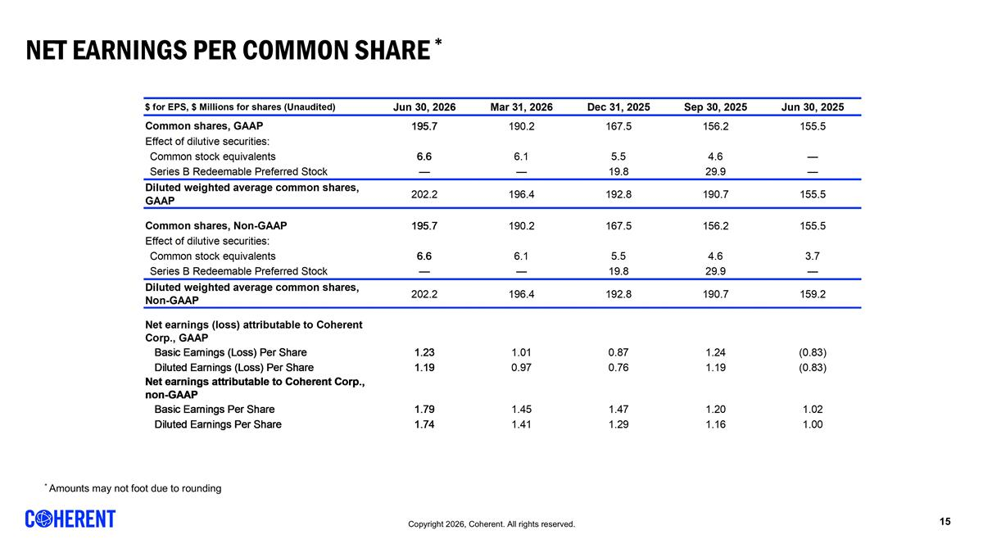
NET Earnings per Common Share * * Amounts may not foot due to rounding REVENUE BY SEGMENT [Data used for bar graph] $ Millions 45,838 45,930 46,022 46,112 46,203 Datacenter and Communications 1,018 1,090 1,208 1,362 1,615 0.79 0.70857315964859136 Industrial 511 491 478 444 431 0.21 Total 1,529 1,581 1,686 1,806 2,046 1 REVENUE BY MARKET [Data used for bar graph] $ Millions 45,838 45,930 46,022 46,112 46,203 Datacenter and Communications 1,018 1,090 1,208 1,362 1,615 0.79 Industrial 511 491 478 444 431 0.21 Total 1,529 1,581 1,686 1,806 2,046 1 REVENUE BY REGION [Data used for bar graph] $ Millions 45,382 45,473 45,565 45,657 45,747 North America 688 756 807 860 944 0.63 0.1 0.37 Europe 182 182 169 167 173 0.12 0.04 -0.05 Japan & Korea 155 167 165 187 177 0.12 -0.05 0.14000000000000001 China 154 173 170 184 161 0.11 rounded to foot -0.13 0.05 Other 30 36 37 37 43 0.03 0.16 0.43 Total 1,209 1,314 1,348 1,435 1,498 1 0.04 0.24 GROSS MARGIN RECONCILIATION $ Millions (Unaudited) 46,203 46,112 46,022 45,930 45,838 Gross margin on GAAP basis 787 680 623 579 546 Share-based compensation 7 6 6 6 6 Amortization of acquired intangibles 28 28 28 28 31 Fair value adjustment on acquired inventory 0 0 Start-up costs 0 0 Integration, site consolidation and other 0 0 0 0 0 Gross margin on non-GAAP basis 823 714 657 613 582 OPERATING EXPENSES RECONCILIATION $ Millions (Unaudited) 46,203 46,112 46,022 45,930 45,838 R&D on GAAP basis 216 186 166 155 156 Share-based compensation -8 -7 -7 -7 -6 Amortization of acquired intangibles 0 0 0 0 0 Start-up costs 0 0 Integration, site consolidation and other R&D on non-GAAP basis 208 178 159 148 150 SG&A on GAAP basis 266 268 259 252 245 Share-based compensation -39 -37 -32 -32 -33 Amortization of acquired intangibles -42 -42 -43 -42 -41 Financing fees 0 0 -1 0 0 Integration, site consolidation and other -17 -19 -21 -23 -14 SG&A on non-GAAP basis 169 170 162 156 157 Restructuring on GAAP basis 6 34 4 19 54 Restructuring -6 -34 -4 -19 -54 Restructuring on non-GAAP basis 0 0 0 0 0 Impairment of assets held-for-sale on GAAP basis 44 0 11 9 85 Impairment of assets held-for-sale -44 0 -11 -9 -85 Impairment of assets held-for-sale on non-GAAP basis 0 0 0 0 0 Gain on sale of business on GAAP basis 0 -9 0 -,115 0 Gain on sale of business 0 9 0 115 0 Gain on sale of business on non-GAAP basis 0 0 0 0 0 INCOME FROM OPERATIONS RECONCILIATION $ Millions (Unaudited) 46,203 46,112 46,022 45,930 45,838 Op. income on GAAP basis 254 201 184 259 6 Share-based compensation 54 51 45 45 44 Fair value adjustment on acquired inventory 0 0 0 0 0 Amortization of acquired intangibles 70 71 71 70 72 Restructuring charges 6 34 4 19 54 Financing fees 0 0 1 0 0 Impairment of assets held-for-sale 44 0 11 9 85 Gain on sale of business 0 -9 0 -,115 0 Integration, site consolidation and other 18 19 21 22 14 Op. income on non-GAAP basis 446 366 336 309 275 Non-GAAP Op. Margin Percentage 0.218 0.20300000000000001 0.19899999999999998 0.19500000000000001 0.18 NET EARNINGS RECONCILIATION $ Millions (Unaudited) 46,203 46,112 46,022 45,930 45,838 Net earnings (loss) attributable to Coherent Corp. on GAAP basis 241 191 147 226 -96 Share-based compensation 54 51 45 45 44 Amortization of acquired intangibles 70 71 71 70 72 Fair value adjustment on acquired inventory 0 0 Start-up costs 0 0 Foreign currency exch. (gains) losses -4 1 -2 -1 37 Restructuring charges 6 34 4 19 54 Impairment of assets held-for-sale 44 0 11 9 85 Gain on sale of business 0 -9 0 -,115 0 Integration, site consolidation and other 18 19 21 22 14 Gain on sale of investment -38 -14 -15 -7 0 Financing fees 0 0 1 12 0 Non-controlling interest impact of non-GAAP items 0 -6 0 0 0 Tax impact of non-GAAP measures -39 -61 -33 -60 -18 Net earnings attributable to Coherent Corp. on non-GAAP basis 351 276 248 221 192 GROSS MARGIN AND EARNINGS PER COMMON SHARE $ Millions (Unaudited) 46,203 46,112 46,022 45,930 45,838 Gross margin on GAAP basis 787 680 623 579 546 Share-based compensation 7 6 6 6 6 Amortization of acquired intangibles 28 28 28 28 31 Integration, site consolidation and other 0 0 0 0 0 Gross margin on non-GAAP basis 823 714 657 613 582 $ for EPS, $ Millions for shares (Unaudited) 46,203 46,112 46,022 45,930 45,838 Common shares, GAAP 195.7 190.2 167.5 156.19999999999999 155.5 Effect of dilutive securities: Common stock equivalents 6.6 6.1 5.5 4.5999999999999996 0 Series B Redeemable Preferred Stock 0 0 19.8 29.9 0 Diluted weighted average common shares, GAAP 202.2 196.4 192.8 190.7 155.5 Common shares, Non-GAAP 195.7 190.2 167.5 156.19999999999999 155.5 Effect of dilutive securities: Common stock equivalents 6.6 6.1 5.5 4.5999999999999996 3.7 Series B Redeemable Preferred Stock 0 0 19.8 29.9 0 Diluted weighted average common shares, Non-GAAP 202.2 196.4 192.8 190.7 159.19999999999999 Net earnings (loss) attributable to Coherent Corp., GAAP Basic Earnings (Loss) Per Share 1.23 1.01 0.87 1.24 -0.83 Diluted Earnings (Loss) Per Share 1.19 0.97 0.76 1.19 -0.83 Net earnings attributable to Coherent Corp., non-GAAP Basic Earnings Per Share 1.79 1.45 1.47 1.2 1.02 Diluted Earnings Per Share 1.74 1.41 1.29 1.1599999999999999 1 NET EARNINGS, GAAP, AND ADJUSTED EBITDA RECONCILIATION $ Millions (Unaudited) 46,203 46,112 46,022 45,930 45,838 Net earnings (loss) on GAAP basis 236 182 144 225 -98 Income taxes (benefit) 42 3 24 -8 35 Depreciation and amortization 141 133 126 122 135 Interest expense 41 45 46 59 55 Interest income -19 -11 -10 -10 -11 EBITDA 441 351 330 389 116 EBITDA margin 0.21600000000000003 0.19399999999999998 0.19600000000000001 0.24600000000000002 7.5999999999999998 Prelim. fair value adj. on acquired inv. 0 0 Share-based compensation 45 51 45 45 44 Foreign currency exch. (gains) losses -2 1 -2 -1 37 Start-up costs 0 0 Restructuring charges 6 34 4 19 54 Impairment of assets held-for-sale 44 0 11 9 85 Gain on sale of business 0 -9 0 -,115 0 Financing fees -38 -14 -14 6 0 Integration, site consolidation and other 18 19 21 22 14 Adjusted EBITDA 521 433 395 347 350 Less: adjusted EBITDA attributable to noncontrolling interests 3 3 1 0 1 Adjusted EBITDA attributable to Coherent Corp. 524 436 396 373 351 Adjusted EBITDA margin attributable to Coherent Corp. 0.25600000000000001 0.24100000000000002 0.23500000000000001 0.23600000000000002 0.22899999999999998 NET EARNINGS RECONCILIATION, GAAP to non-GAAP $ Millions (Unaudited) 46,203 Net earnings attributable to Coherent Corp. on GAAP basis 241 Share-based compensation 54 Amortization of acquired intangibles 70 Foreign currency exch. (gains) losses -4 Restructuring charges 6 Impairment of assets held-for-sale 44 Gain on sale of business 0 Integration, site consolidation and other 18 Gain on sale of investment -38 Financing fees 0 Non-controlling interest impact of non-GAAP items 0 Tax impact of non-GAAP measures -39 Net earnings attributable to Coherent Corp. on non-GAAP basis 351 Basic weighted average shares, GAAP 195.7 Diluted weighted average shares, GAAP 202.2 Diluted weighted average shares, non-GAAP 202.2 Net diluted earnings per share attributable to Coherent Corp., GAAP $1.19 Net earnings per share attributable to Coherent Corp., non-GAAP $1.74 REVENUE BY SEGMENT [Data used for bar graph] $ Millions 45,838 45,930 46,022 46,112 46,203 Datacenter and Communications 1,018 1,090 1,208 1,362 1,615 0.79 0.70857315964859136 Industrial 511 491 478 444 431 0.21 Total 1,529 1,581 1,686 1,806 2,046 1 REVENUE BY MARKET [Data used for bar graph] $ Millions 45,838 45,930 46,022 46,112 46,203 Datacenter and Communications 1,018 1,090 1,208 1,362 1,615 0.79 Industrial 511 491 478 444 431 0.21 Total 1,529 1,581 1,686 1,806 2,046 1 REVENUE BY REGION [Data used for bar graph] $ Millions 45,382 45,473 45,565 45,657 45,747 North America 688 756 807 860 944 0.63 0.1 0.37 Europe 182 182 169 167 173 0.12 0.04 -0.05 Japan & Korea 155 167 165 187 177 0.12 -0.05 0.14000000000000001 China 154 173 170 184 161 0.11 rounded to foot -0.13 0.05 Other 30 36 37 37 43 0.03 0.16 0.43 Total 1,209 1,314 1,348 1,435 1,498 1 0.04 0.24 GROSS MARGIN RECONCILIATION $ Millions (Unaudited) 46,203 46,112 46,022 45,930 45,838 Gross margin on GAAP basis 787 680 623 579 546 Share-based compensation 7 6 6 6 6 Amortization of acquired intangibles 28 28 28 28 31 Fair value adjustment on acquired inventory 0 0 Start-up costs 0 0 Integration, site consolidation and other 0 0 0 0 0 Gross margin on non-GAAP basis 823 714 657 613 582 OPERATING EXPENSES RECONCILIATION $ Millions (Unaudited) 46,203 46,112 46,022 45,930 45,838 R&D on GAAP basis 216 186 166 155 156 Share-based compensation -8 -7 -7 -7 -6 Amortization of acquired intangibles 0 0 0 0 0 Start-up costs 0 0 Integration, site consolidation and other R&D on non-GAAP basis 208 178 159 148 150 SG&A on GAAP basis 266 268 259 252 245 Share-based compensation -39 -37 -32 -32 -33 Amortization of acquired intangibles -42 -42 -43 -42 -41 Financing fees 0 0 -1 0 0 Integration, site consolidation and other -17 -19 -21 -23 -14 SG&A on non-GAAP basis 169 170 162 156 157 Restructuring on GAAP basis 6 34 4 19 54 Restructuring -6 -34 -4 -19 -54 Restructuring on non-GAAP basis 0 0 0 0 0 Impairment of assets held-for-sale on GAAP basis 44 0 11 9 85 Impairment of assets held-for-sale -44 0 -11 -9 -85 Impairment of assets held-for-sale on non-GAAP basis 0 0 0 0 0 Gain on sale of business on GAAP basis 0 -9 0 -,115 0 Gain on sale of business 0 9 0 115 0 Gain on sale of business on non-GAAP basis 0 0 0 0 0 INCOME FROM OPERATIONS RECONCILIATION $ Millions (Unaudited) 46,203 46,112 46,022 45,930 45,838 Op. income on GAAP basis 254 201 184 259 6 Share-based compensation 54 51 45 45 44 Fair value adjustment on acquired inventory 0 0 0 0 0 Amortization of acquired intangibles 70 71 71 70 72 Restructuring charges 6 34 4 19 54 Financing fees 0 0 1 0 0 Impairment of assets held-for-sale 44 0 11 9 85 Gain on sale of business 0 -9 0 -,115 0 Integration, site consolidation and other 18 19 21 22 14 Op. income on non-GAAP basis 446 366 336 309 275 Non-GAAP Op. Margin Percentage 0.218 0.20300000000000001 0.19899999999999998 0.19500000000000001 0.18 NET EARNINGS RECONCILIATION $ Millions (Unaudited) 46,203 46,112 46,022 45,930 45,838 Net earnings (loss) attributable to Coherent Corp. on GAAP basis 241 191 147 226 -96 Share-based compensation 54 51 45 45 44 Amortization of acquired intangibles 70 71 71 70 72 Fair value adjustment on acquired inventory 0 0 Start-up costs 0 0 Foreign currency exch. (gains) losses -4 1 -2 -1 37 Restructuring charges 6 34 4 19 54 Impairment of assets held-for-sale 44 0 11 9 85 Gain on sale of business 0 -9 0 -,115 0 Integration, site consolidation and other 18 19 21 22 14 Gain on sale of investment -38 -14 -15 -7 0 Financing fees 0 0 1 12 0 Non-controlling interest impact of non-GAAP items 0 -6 0 0 0 Tax impact of non-GAAP measures -39 -61 -33 -60 -18 Net earnings attributable to Coherent Corp. on non-GAAP basis 351 276 248 221 192 GROSS MARGIN AND EARNINGS PER COMMON SHARE $ Millions (Unaudited) 46,203 46,112 46,022 45,930 45,838 Gross margin on GAAP basis 787 680 623 579 546 Share-based compensation 7 6 6 6 6 Amortization of acquired intangibles 28 28 28 28 31 Integration, site consolidation and other 0 0 0 0 0 Gross margin on non-GAAP basis 823 714 657 613 582 $ for EPS, $ Millions for shares (Unaudited) 46,203 46,112 46,022 45,930 45,838 Common shares, GAAP 195.7 190.2 167.5 156.19999999999999 155.5 Effect of dilutive securities: Common stock equivalents 6.6 6.1 5.5 4.5999999999999996 0 Series B Redeemable Preferred Stock 0 0 19.8 29.9 0 Diluted weighted average common shares, GAAP 202.2 196.4 192.8 190.7 155.5 Common shares, Non-GAAP 195.7 190.2 167.5 156.19999999999999 155.5 Effect of dilutive securities: Common stock equivalents 6.6 6.1 5.5 4.5999999999999996 3.7 Series B Redeemable Preferred Stock 0 0 19.8 29.9 0 Diluted weighted average common shares, Non-GAAP 202.2 196.4 192.8 190.7 159.19999999999999 Net earnings (loss) attributable to Coherent Corp., GAAP Basic Earnings (Loss) Per Share 1.23 1.01 0.87 1.24 -0.83 Diluted Earnings (Loss) Per Share 1.19 0.97 0.76 1.19 -0.83 Net earnings attributable to Coherent Corp., non-GAAP Basic Earnings Per Share 1.79 1.45 1.47 1.2 1.02 Diluted Earnings Per Share 1.74 1.41 1.29 1.1599999999999999 1 NET EARNINGS, GAAP, AND ADJUSTED EBITDA RECONCILIATION $ Millions (Unaudited) 46,203 46,112 46,022 45,930 45,838 Net earnings (loss) on GAAP basis 236 182 144 225 -98 Income taxes (benefit) 42 3 24 -8 35 Depreciation and amortization 141 133 126 122 135 Interest expense 41 45 46 59 55 Interest income -19 -11 -10 -10 -11 EBITDA 441 351 330 389 116 EBITDA margin 0.21600000000000003 0.19399999999999998 0.19600000000000001 0.24600000000000002 7.5999999999999998 Prelim. fair value adj. on acquired inv. 0 0 Share-based compensation 45 51 45 45 44 Foreign currency exch. (gains) losses -2 1 -2 -1 37 Start-up costs 0 0 Restructuring charges 6 34 4 19 54 Impairment of assets held-for-sale 44 0 11 9 85 Gain on sale of business 0 -9 0 -,115 0 Financing fees -38 -14 -14 6 0 Integration, site consolidation and other 18 19 21 22 14 Adjusted EBITDA 521 433 395 347 350 Less: adjusted EBITDA attributable to noncontrolling interests 3 3 1 0 1 Adjusted EBITDA attributable to Coherent Corp. 524 436 396 373 351 Adjusted EBITDA margin attributable to Coherent Corp. 0.25600000000000001 0.24100000000000002 0.23500000000000001 0.23600000000000002 0.22899999999999998 NET EARNINGS RECONCILIATION, GAAP to non-GAAP $ Millions (Unaudited) 46,203 Net earnings attributable to Coherent Corp. on GAAP basis 241 Share-based compensation 54 Amortization of acquired intangibles 70 Foreign currency exch. (gains) losses -4 Restructuring charges 6 Impairment of assets held-for-sale 44 Gain on sale of business 0 Integration, site consolidation and other 18 Gain on sale of investment -38 Financing fees 0 Non-controlling interest impact of non-GAAP items 0 Tax impact of non-GAAP measures -39 Net earnings attributable to Coherent Corp. on non-GAAP basis 351 Basic weighted average shares, GAAP 195.7 Diluted weighted average shares, GAAP 202.2 Diluted weighted average shares, non-GAAP 202.2 Net diluted earnings per share attributable to Coherent Corp., GAAP $1.19 Net earnings per share attributable to Coherent Corp., non-GAAP $1.74

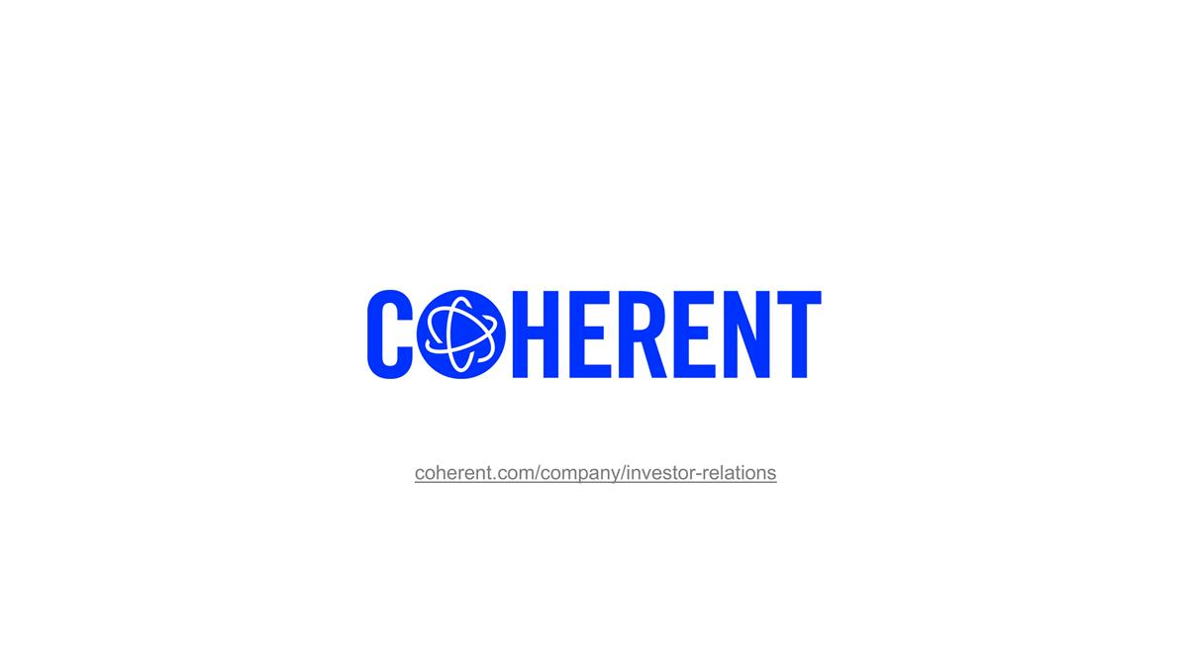
coherent.com/company/investor-relations

